### Create a deployment pipeline between VSTS and AWS Elastic Beanstalk

Tools/Services used

1. Visual Studio Team Services a.k.a VSTS
   1. Git for source control
   2. Build and Deployment pipeline
2. AWS Beanstalk
3. VSTS Toolkit for Visual Studio
4. AWS Tools for Visual Studio Team Services

Goal

Use VSTS as a CI/CD platform and build a pipeline to build and deploy an ASP.NET Core application to AWS Beanstalk

Assumptions

This guide assumes that:

1. The reader already has an account on Microsoft Visual Studio Team Services
2. Has basic understanding of Git source control system
3. Has knowledge on DevOps and CICD pipelines
4. Has basic knowledge about AWS Beanstalk

Environment Preparation

1. Install Git on your Windows Machine if it’s not installed already - <https://git-scm.com/download>
2. Install AWS Tools for Visual Studio Team Services from <https://marketplace.visualstudio.com/items?itemName=AmazonWebServices.aws-vsts-tools>

##### Installation

1. 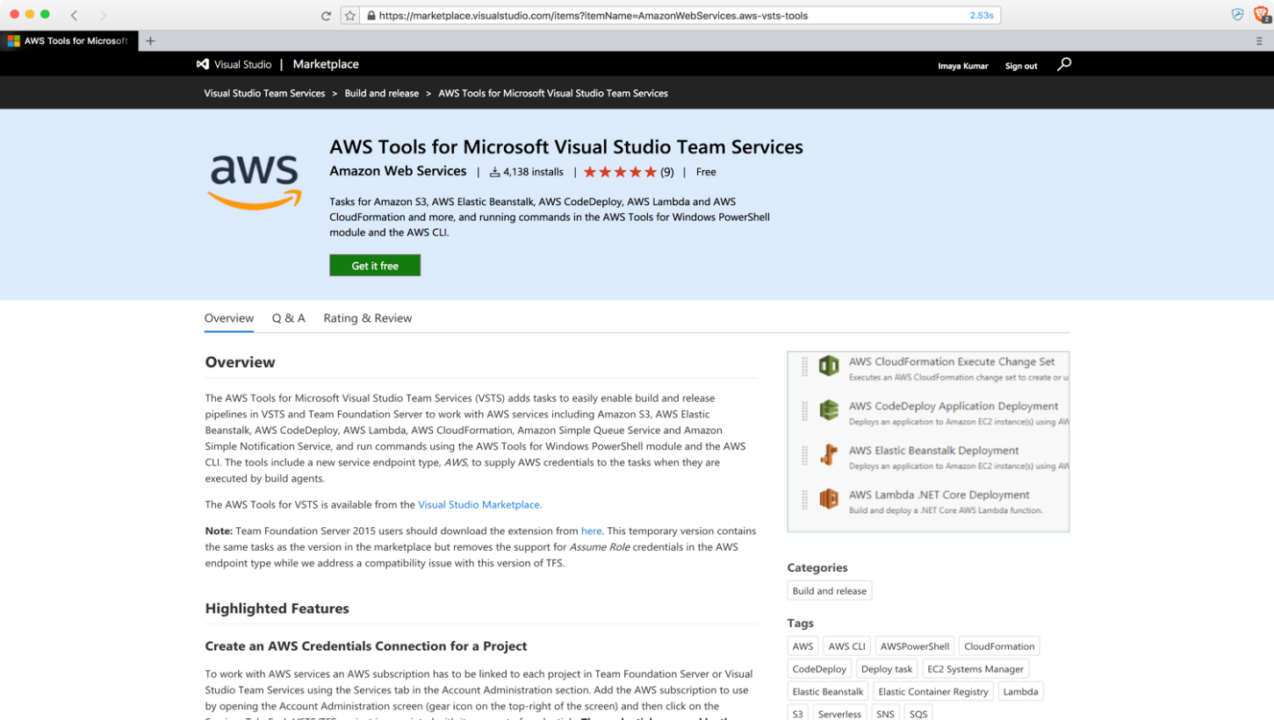Follow the installation process [here](https://docs.aws.amazon.com/vsts/latest/userguide/getting-started.html) to add the extension to your VSTS account. After you add the extension, ensure it appears under your settings pane.

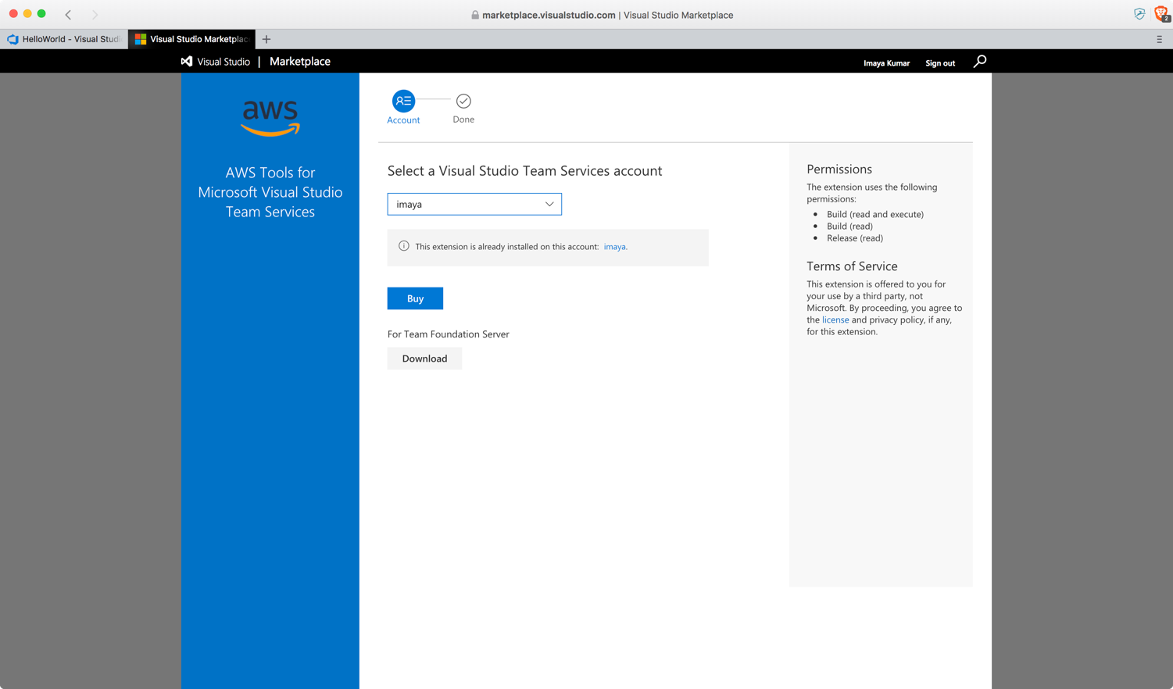

1. Though not mandatory for this exercise, we also recommend you to install AWS Toolkit for Visual Studio because of its powerful features that you will find useful in your development journey. It is available as a Visual Studio add-on for Windows and can be found under the Visual Studio tab in the Visual Studio Marketplace. In this exercise, I installed the add-on for Visual Studio 2017 version.

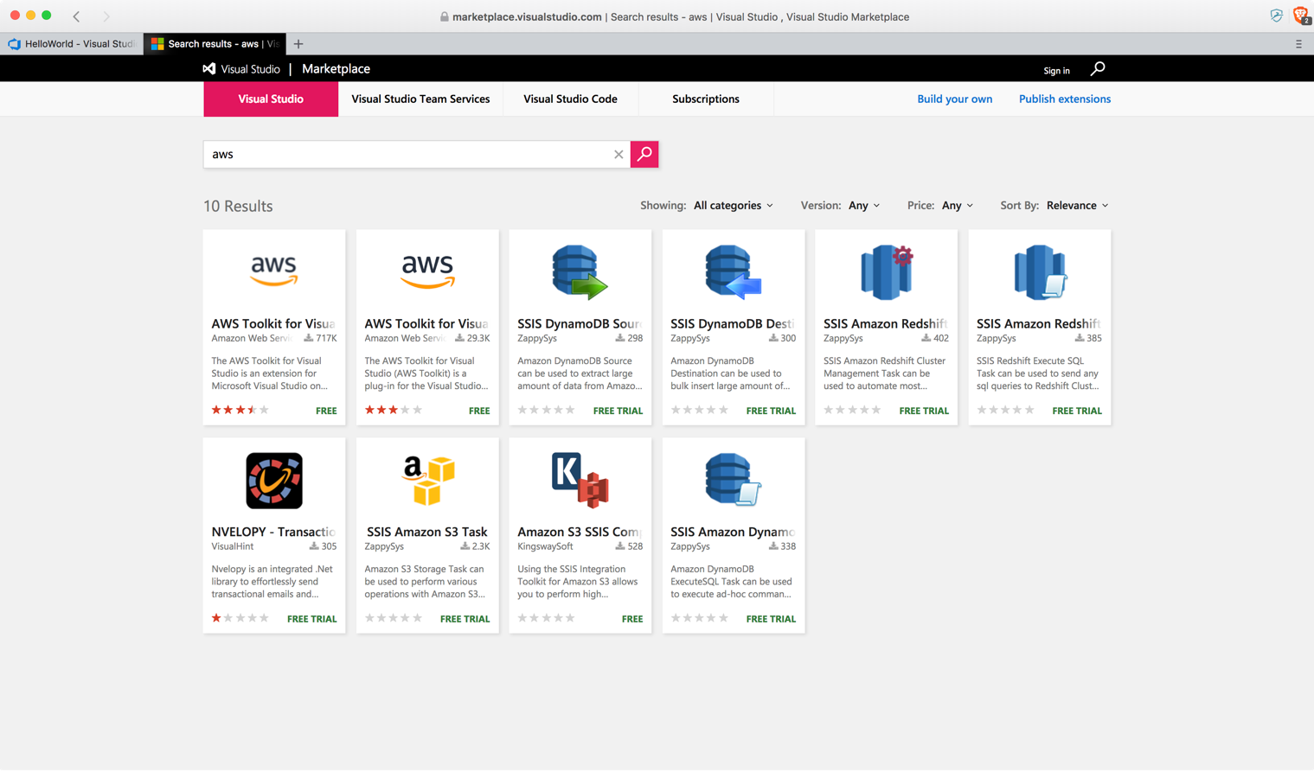

##### Steps

1. Head to VSTS and create a new Project and name it HelloWorld. Ensure you choose Git as the source control option.

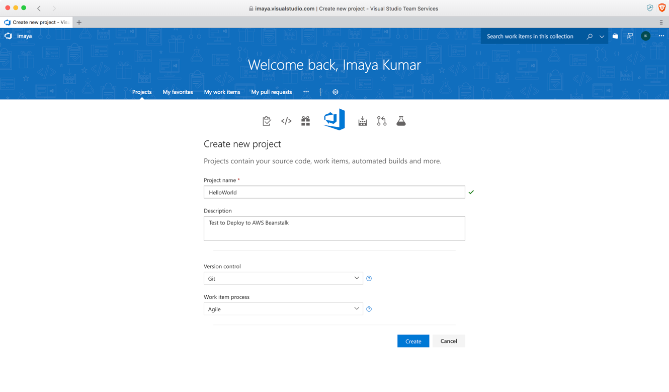

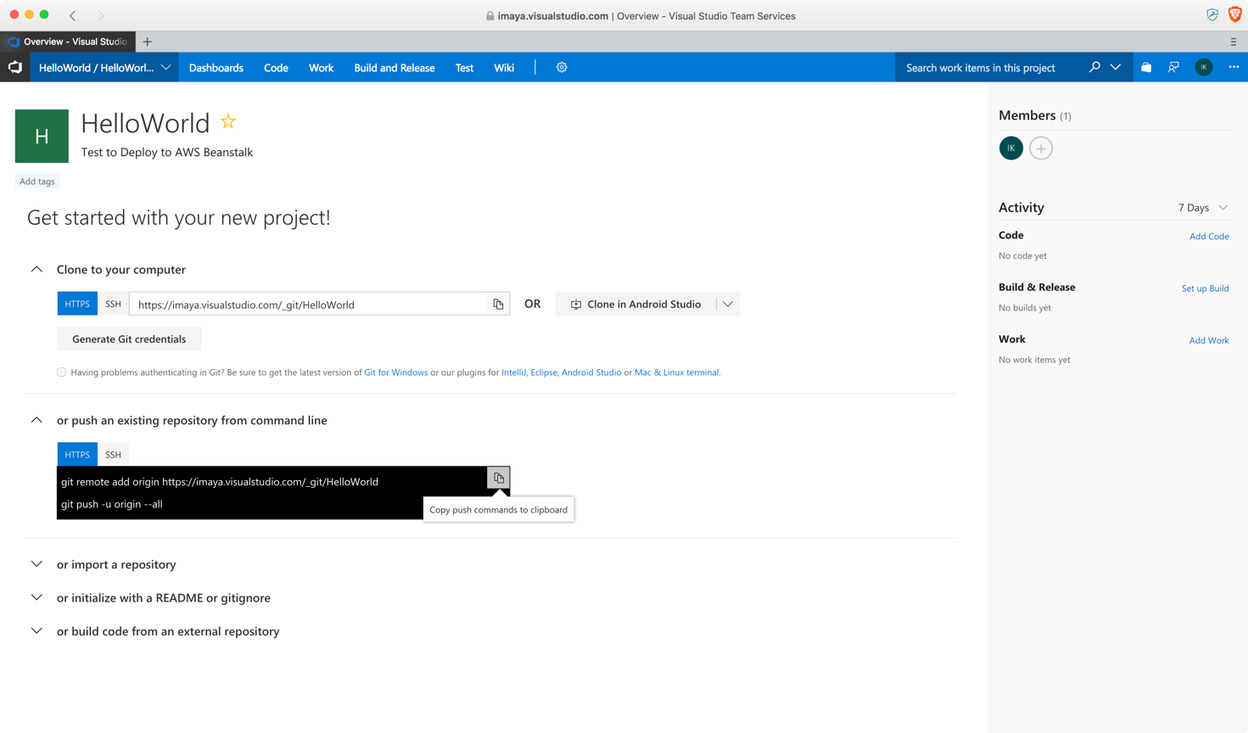

1. Open Visual Studio on Windows and create a new project choosing the ASP.NET Core Web Application template

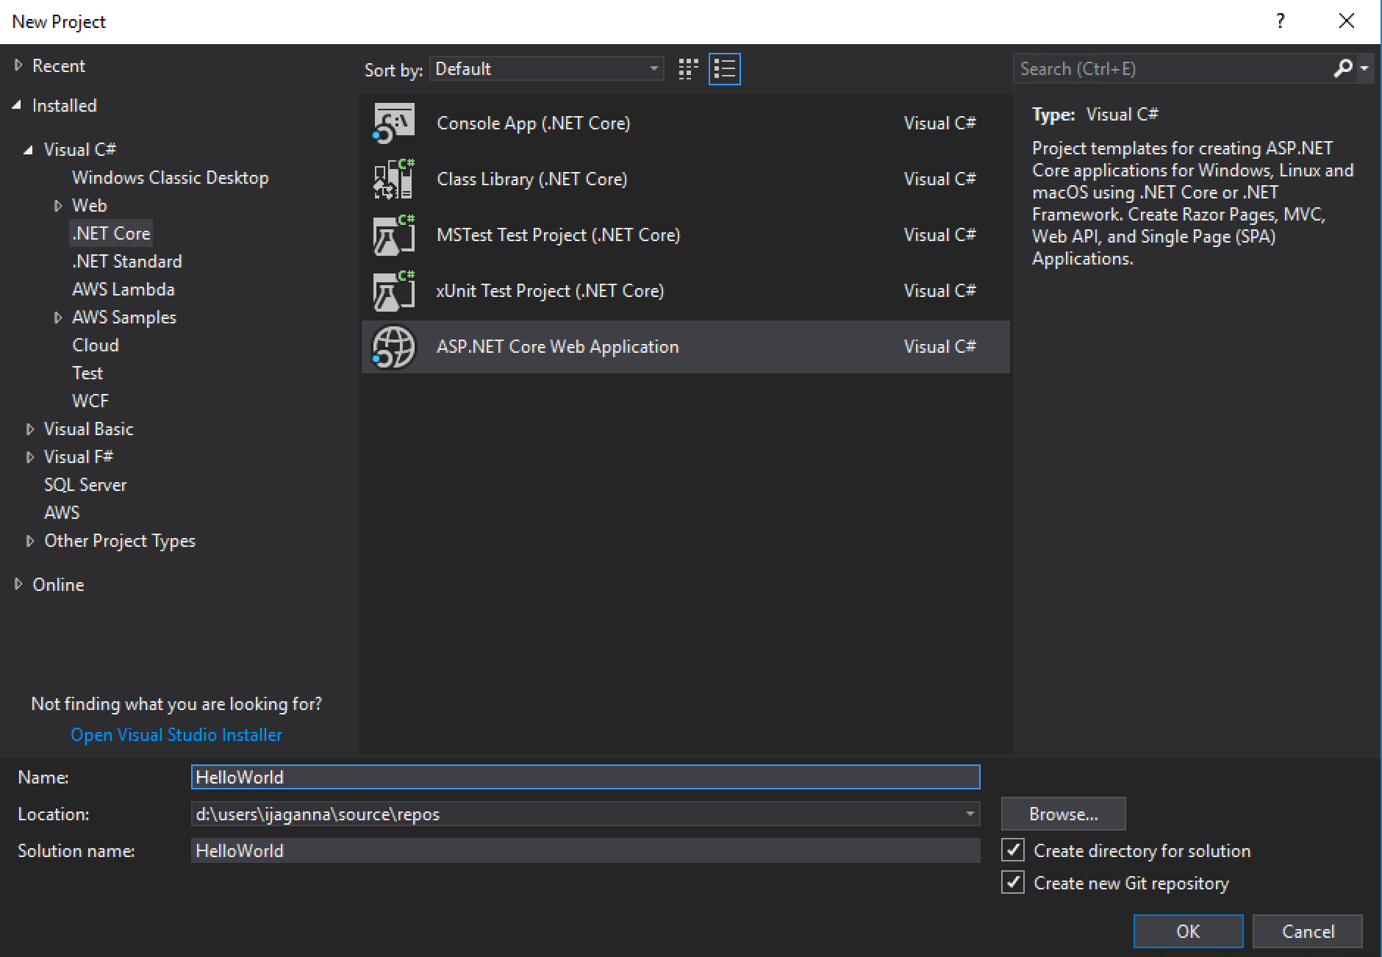

1. Make sure ASP.NET Core 2.0 is selected in the drop down and Web Application template is selected as well

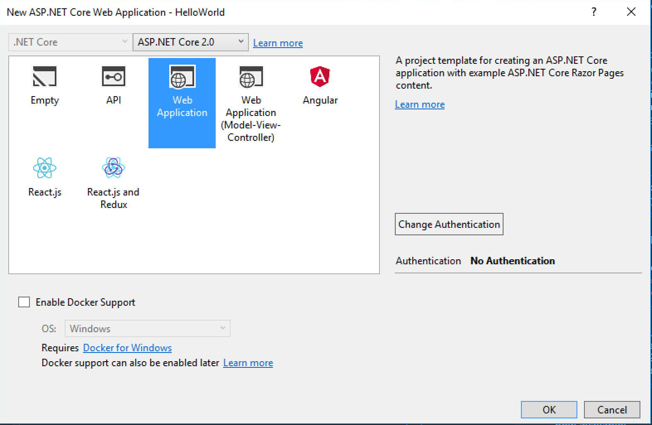

1. Once the project is created, open *Powershell* and navigate to the project source folder and push the source code to the VSTS Git repository you just created

git remote add origin https*://<your-instance-name>*.visualstudio.com/_git/HelloWorld

git push -u origin --all

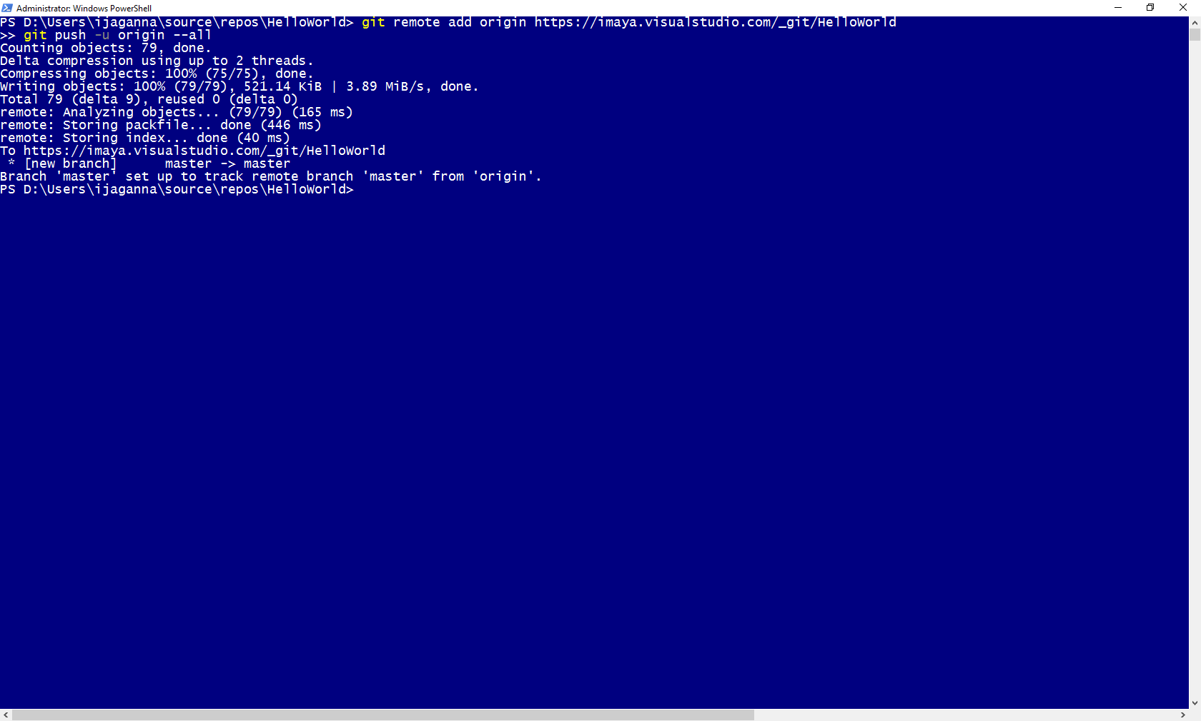

1. Open AWS Console and navigate to Beanstalk service home page and click on **Create New Application**

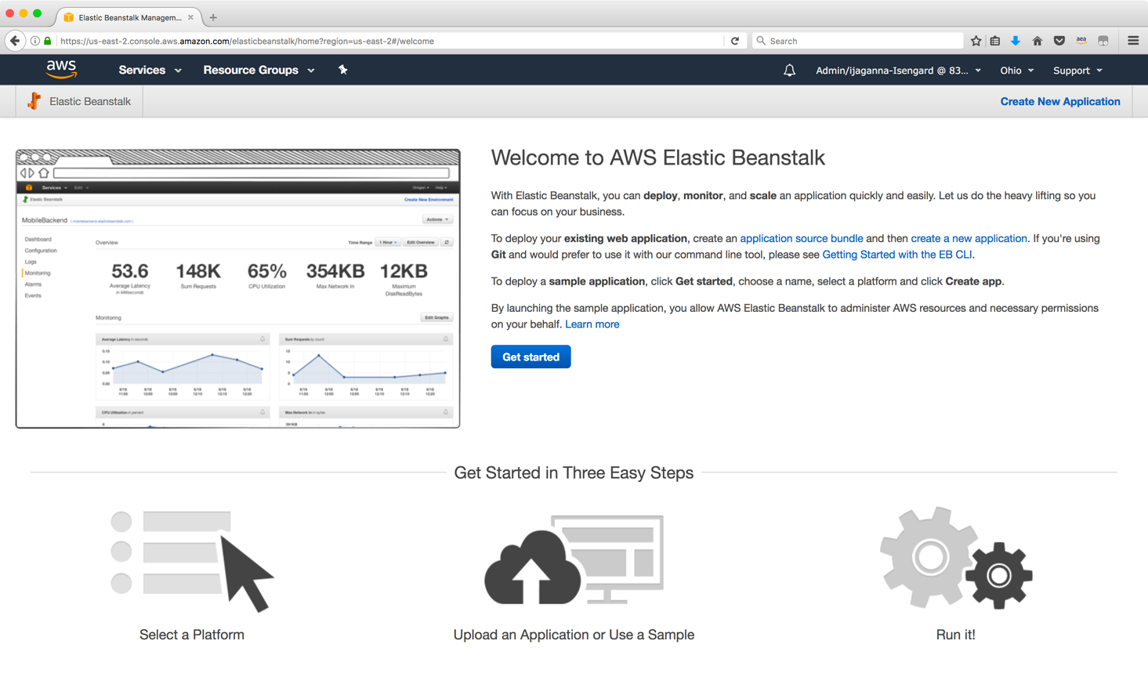

1. Give the application a name and select other options as shown in the screenshot below.

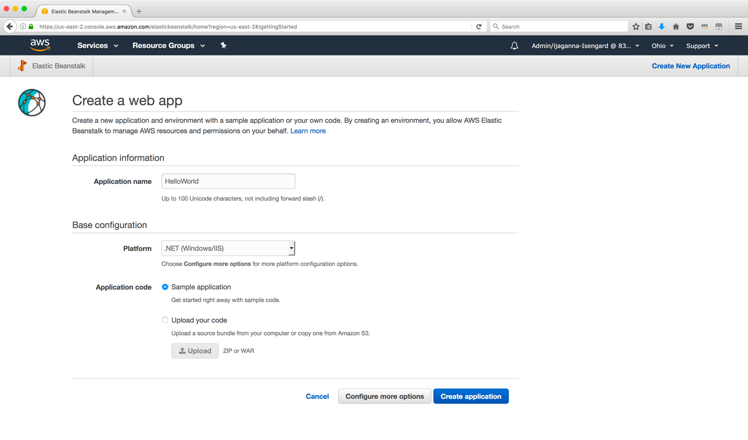

1. After you click on **Create application,** AWS will start provisioning all required components for your Beanstalk application.

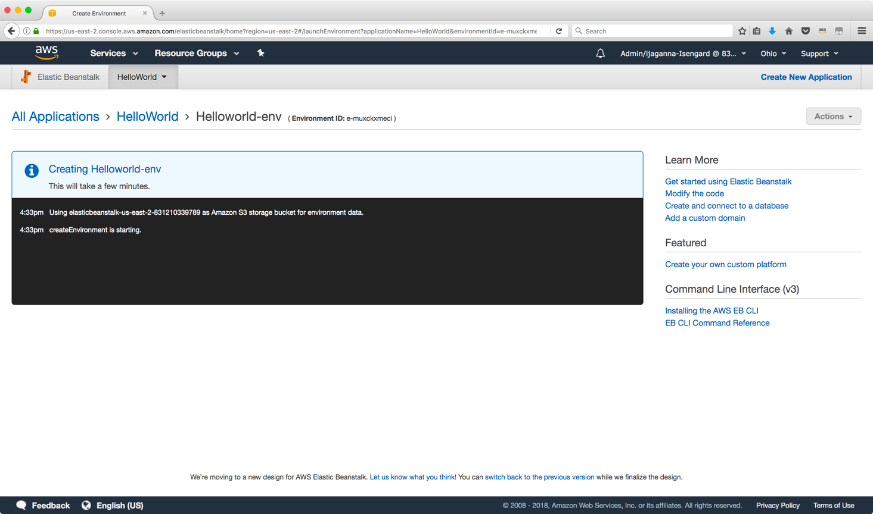

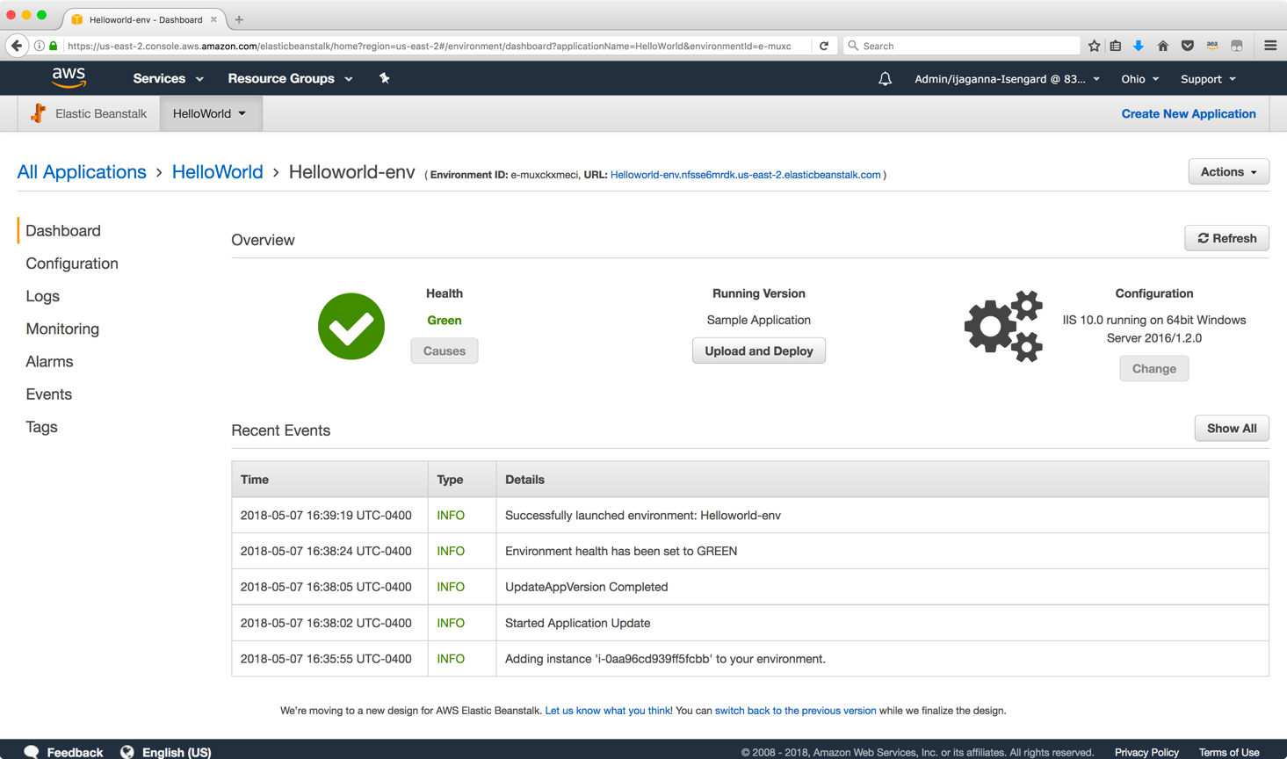

1. After you see this green check mark, click on the generated URL for your Beanstalk application that has the sample app built in. Your browser should open a new tab and show a page similar to the one below. This indicates successful creation of your new Beanstalk application.

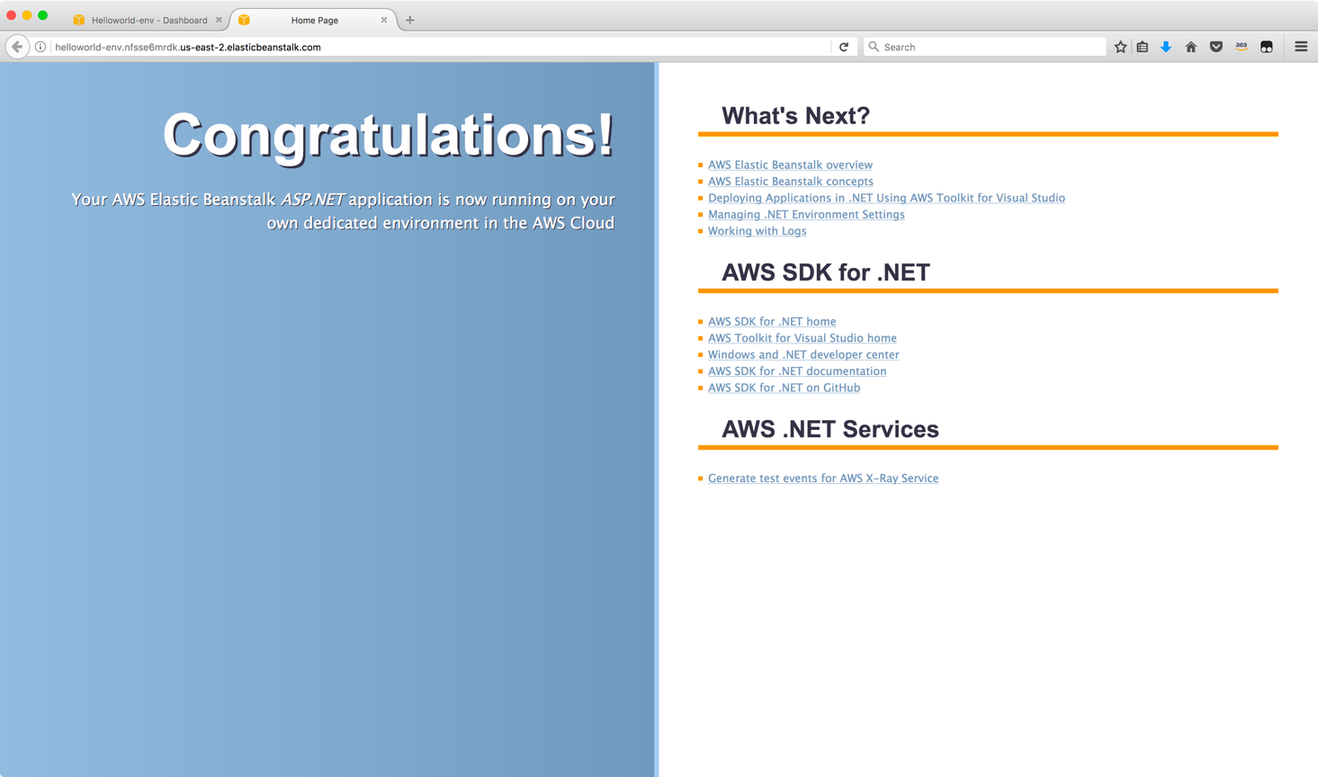

1. Now that you have the target environment with sample application setup and also your code pushed to VSTS, it’s time to setup the Build and Deploy pipeline.
2. Navigate to your project home page on VSTS and you should see something similar to the screen below

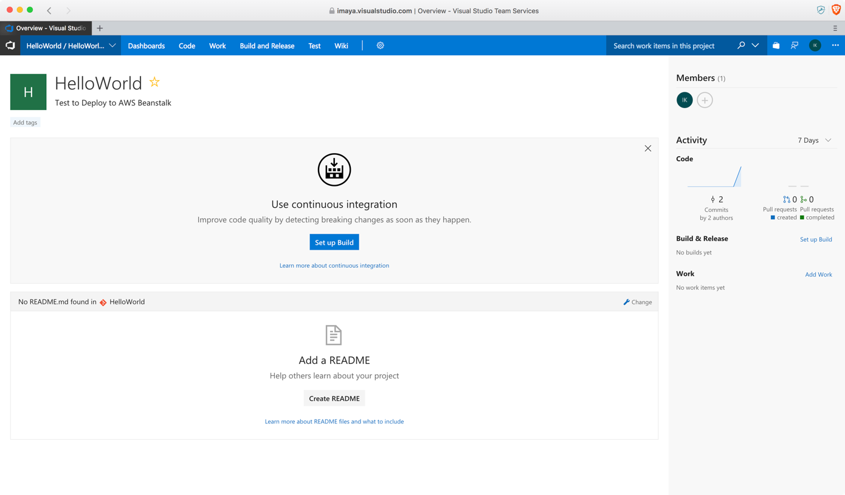

1. Click on **Set up Build** and it should take you to a screen like the one below. Select **VSTS Git** as your source control. Rest of the fields should be automatically populated. Leave the default values as is and click **Continue.**

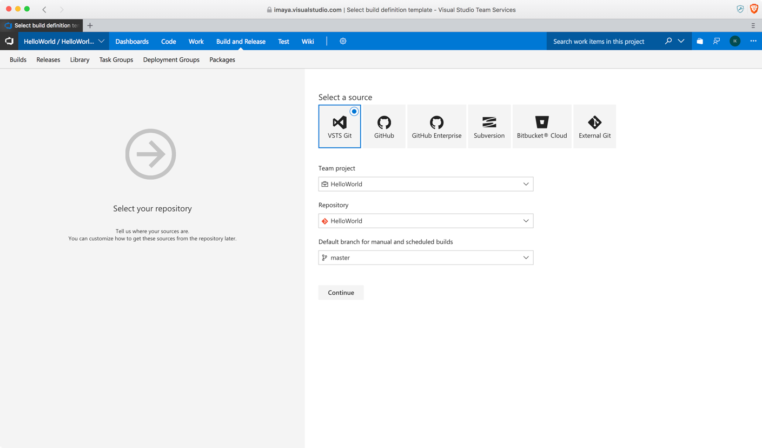

1. The next screen allows you to select the template that is already built into VSTS. Choose **ASP.NET Core** option and click **Apply** since that is the framework our solution is based on.

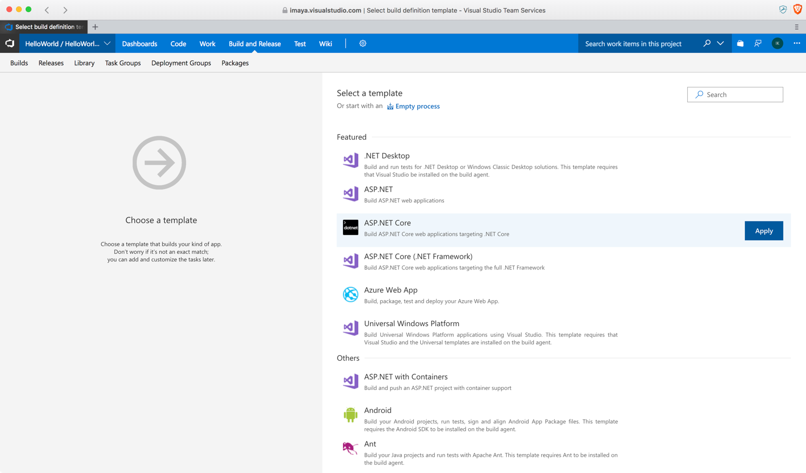

1. The next screen should look similar to the one below. It contains all the tasks that the **Build** process will go through. All fields in this screen should be automatically populated, so leave them as is and click on **Save & queue.**

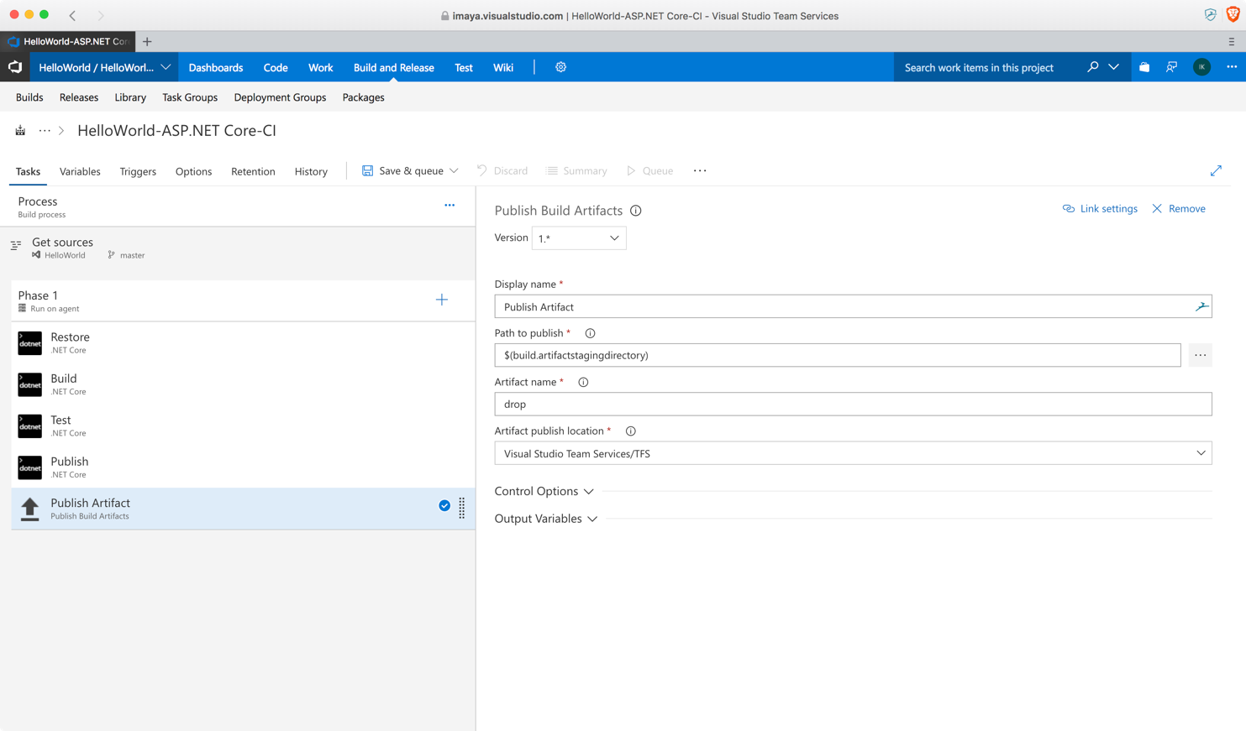

1. Save the template and click on **Queue.**

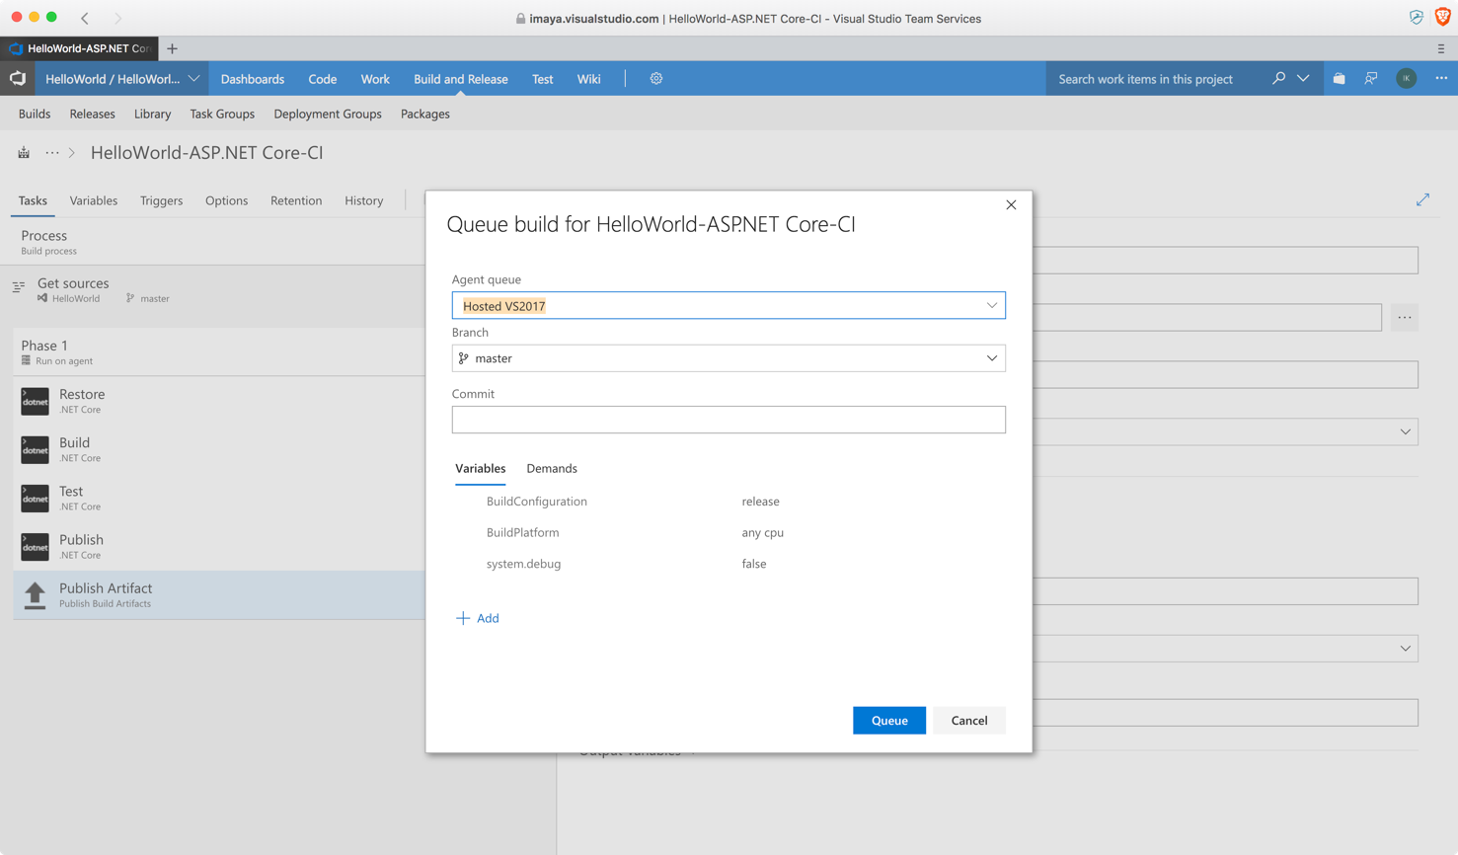

1. VSTS will start executing the Build tasks one by one in a sequential order.

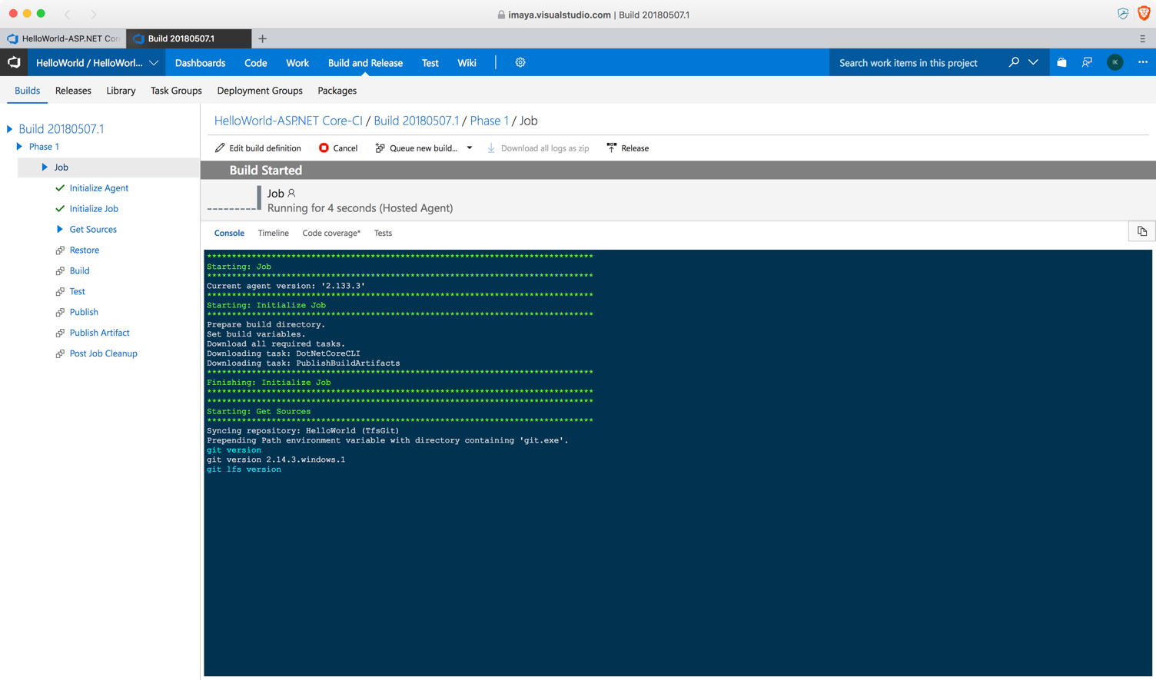

1. The below screen indicates that the Build process has been successful and the final build output file has been placed under the **jobs** folder on the Build server.

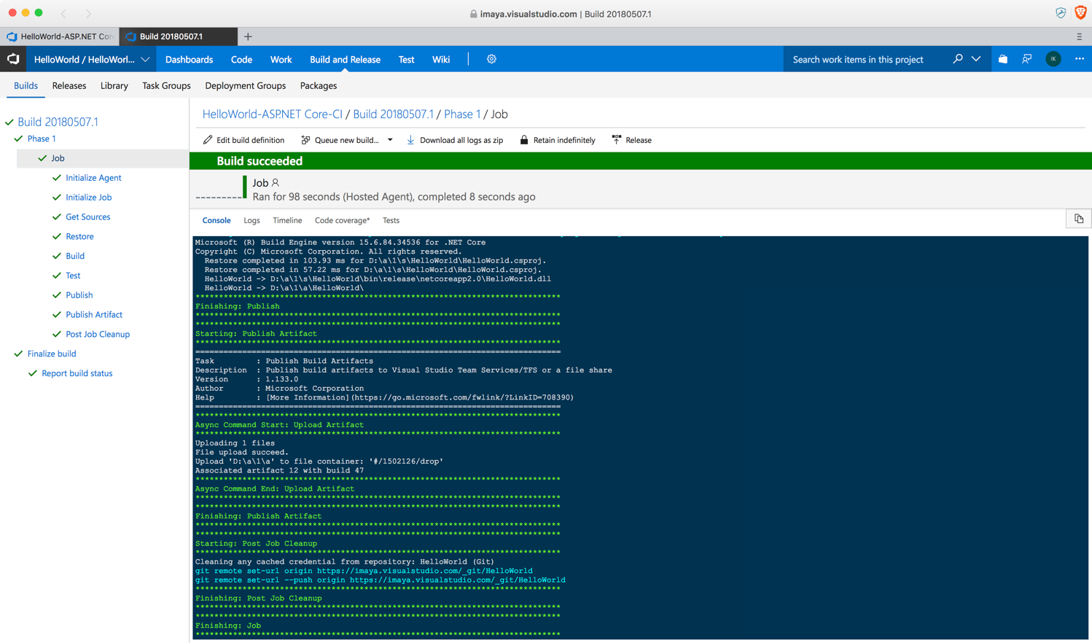

1. Next step is to create a Release template so we can deploy the build output to our AWS Beanstalk environment. Go to the **Releases** tab on VSTS and you should see a screen similar to this. Click on **New definition.**

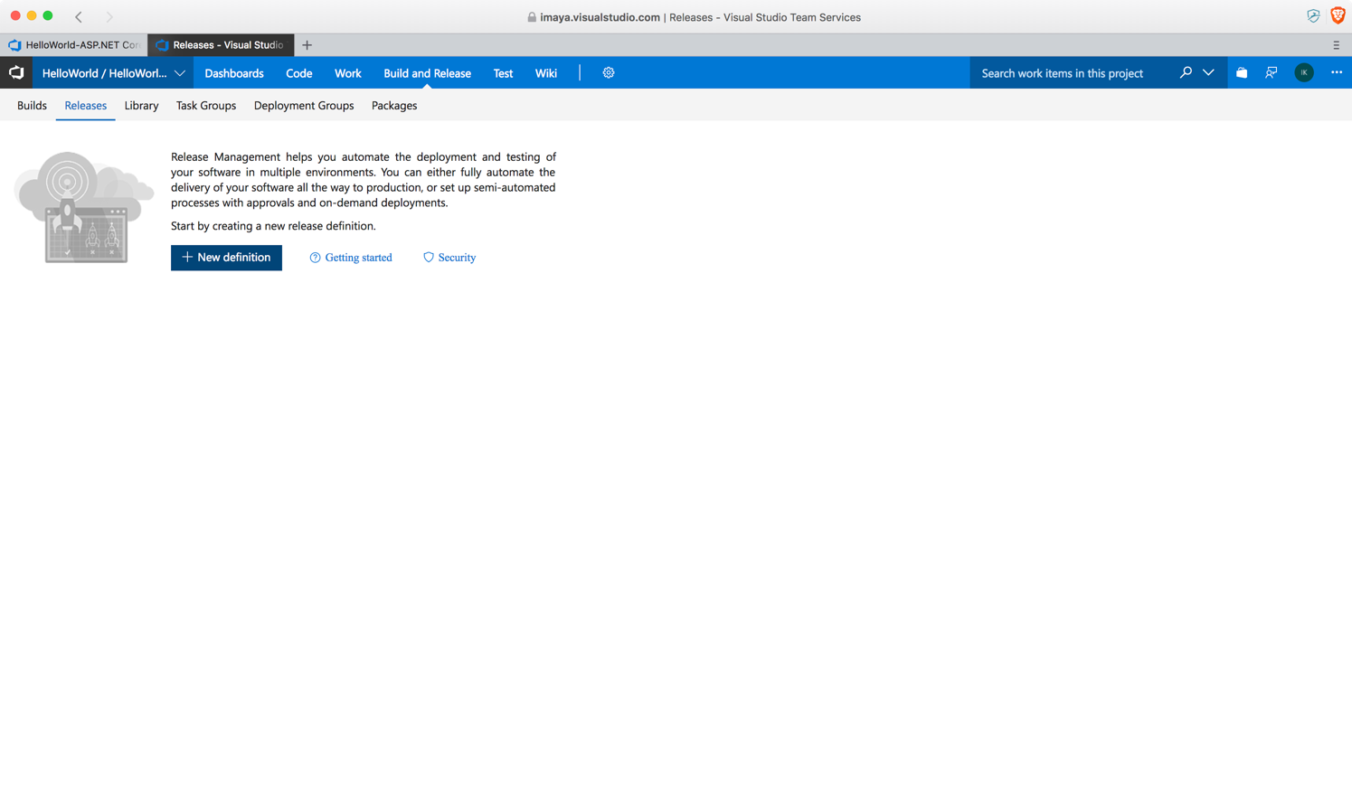

1. In the next screen, under Select a Template, click **Empty process.**

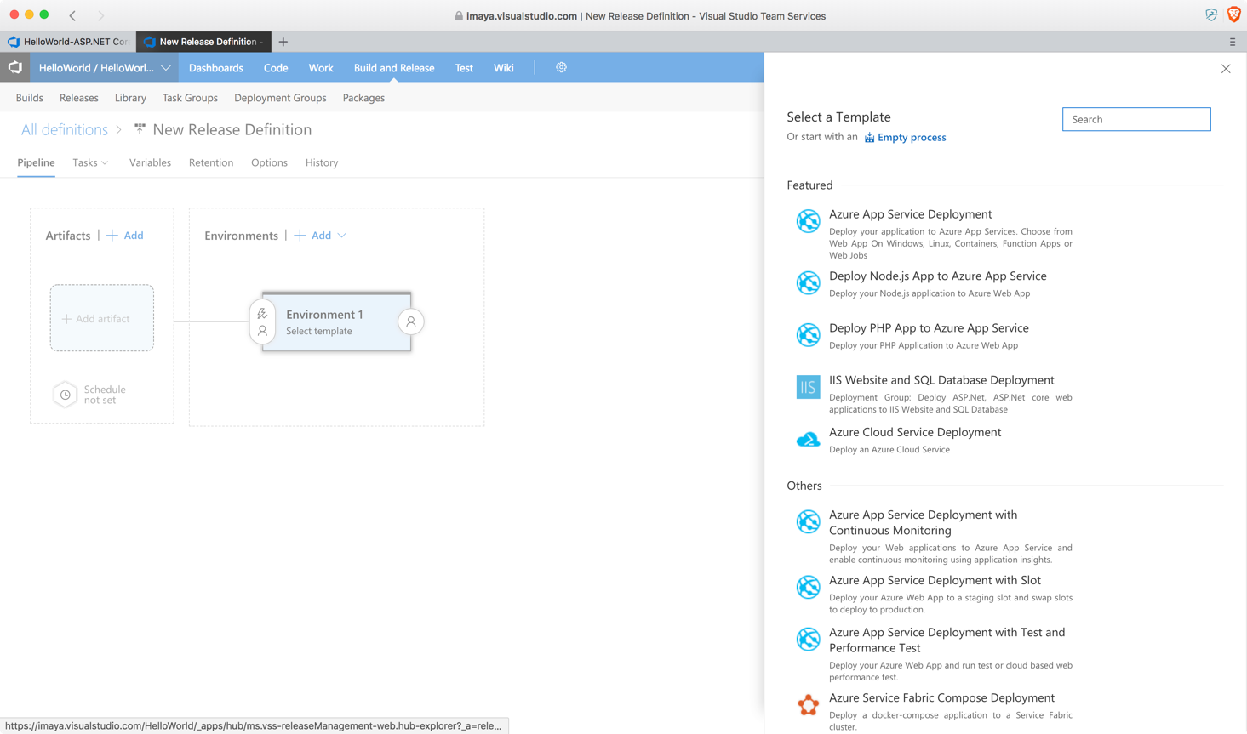

1. Click **1 phase, 0 task** link and rename the environment if you like or leave it to default value as shown below and click **Save.**

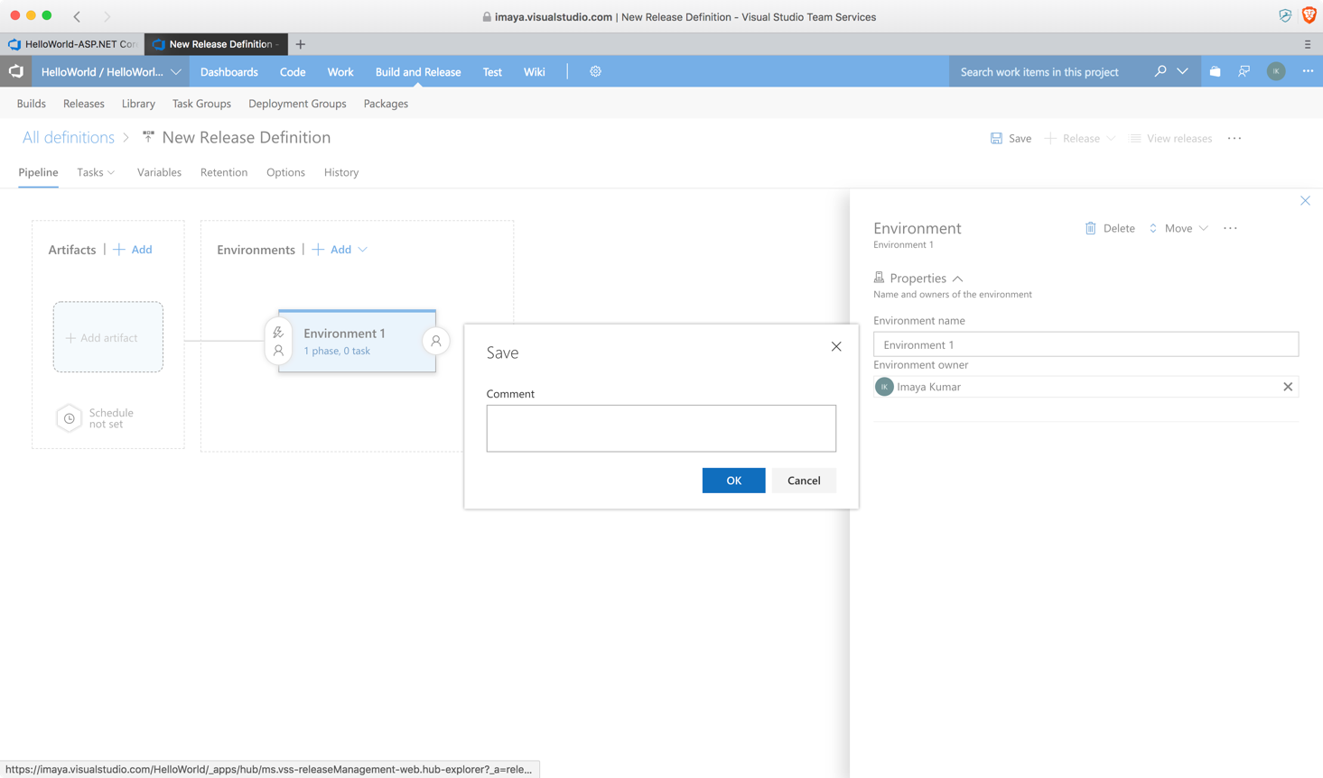

1. In this next screen, click on ‘**+’** to add a new task to the Release definition.

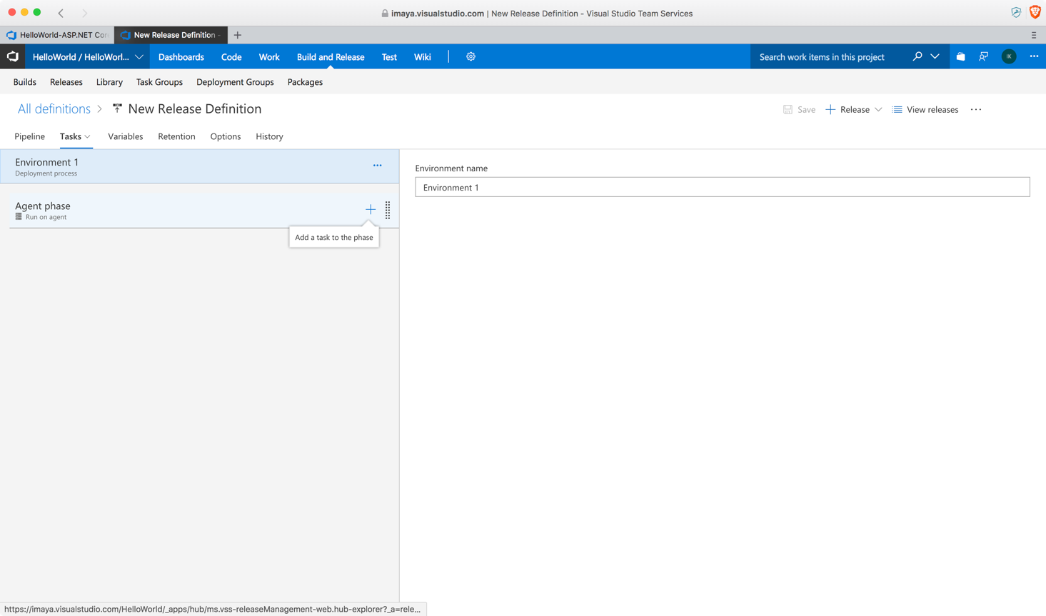

1. You will be presented with several options as shown below. Scroll down until you see **AWS Elastic Beanstalk Deploy Application** and click **Add.** You will only see the AWS related tasks in the list if you had already installed the AWS Tools for VSTS add-in as mentioned earlier in this post.

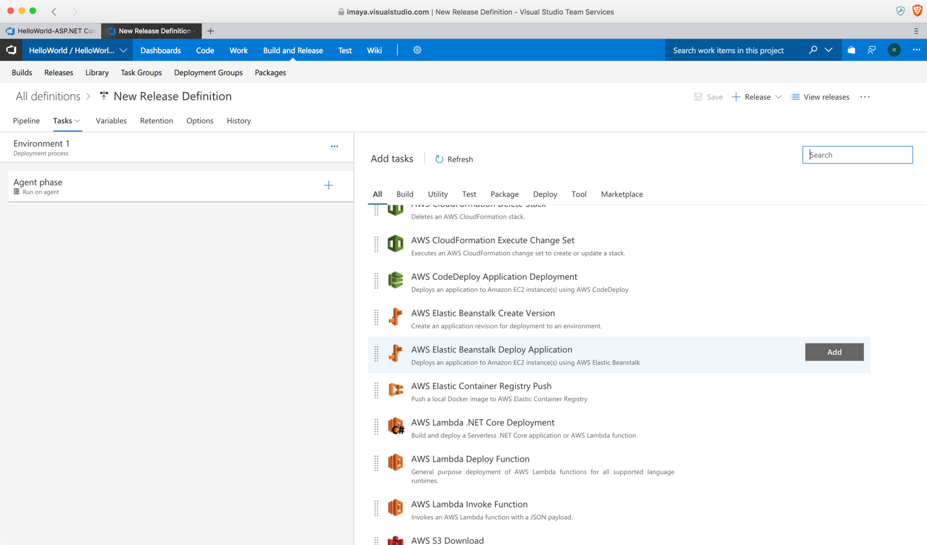

1. You will have to configure your AWS Credentials on VSTS for this task to deploy the application on your Elastic Beanstalk instance. To configure the credentials, click on **+ New** button.

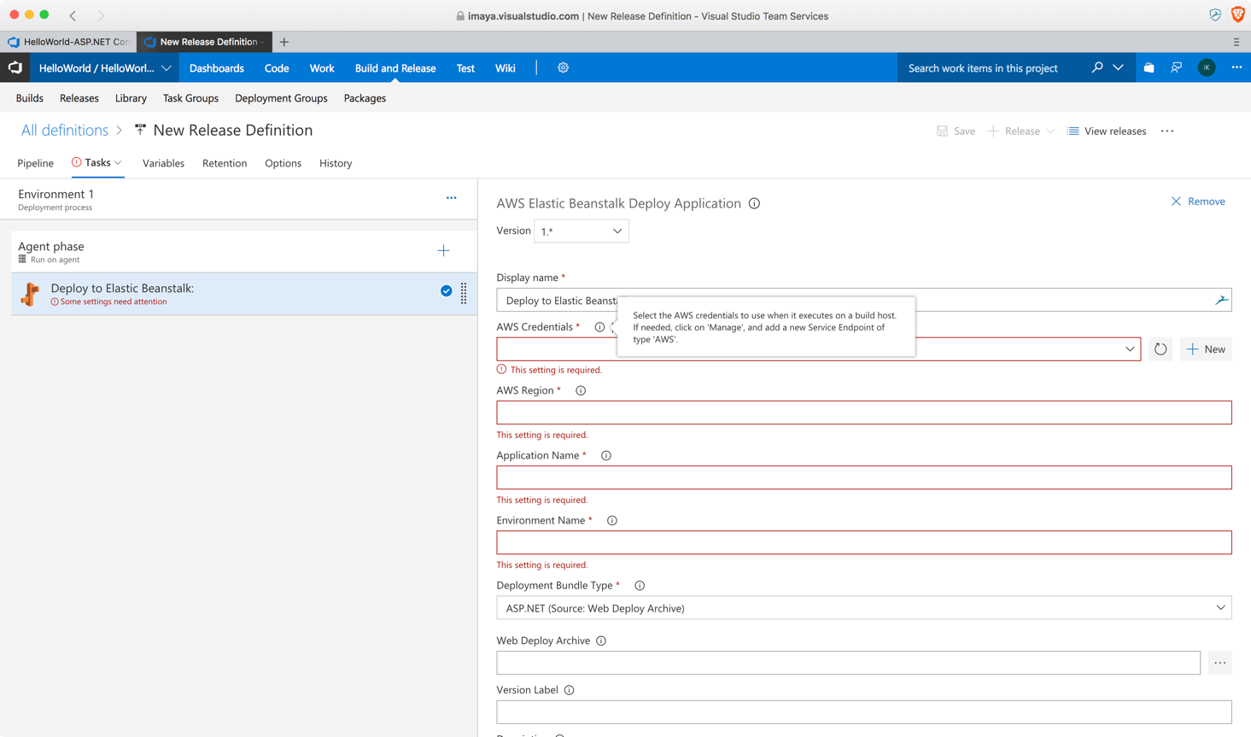

1. In the next screen, select **AWS** from the drop down.

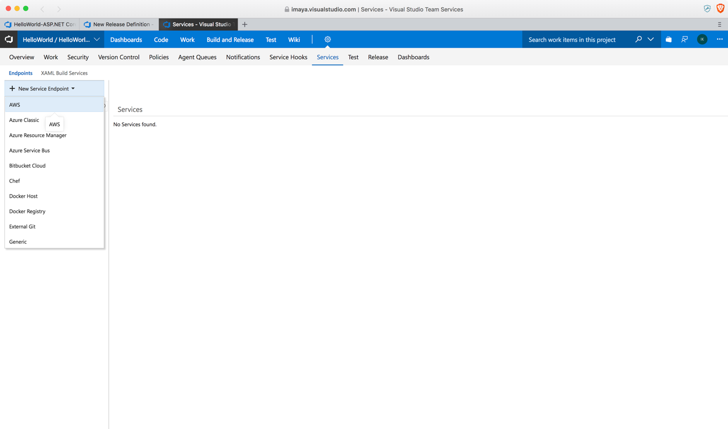

1. VSTS will show this screen where you can enter the **Access Key ID** and **Secret Access Key** that belongs to your IAM user account on AWS portal. Give the connection a name and fill in the Access Key ID and Secret Access Key fields only. Leave others blank as they are not mandatory.

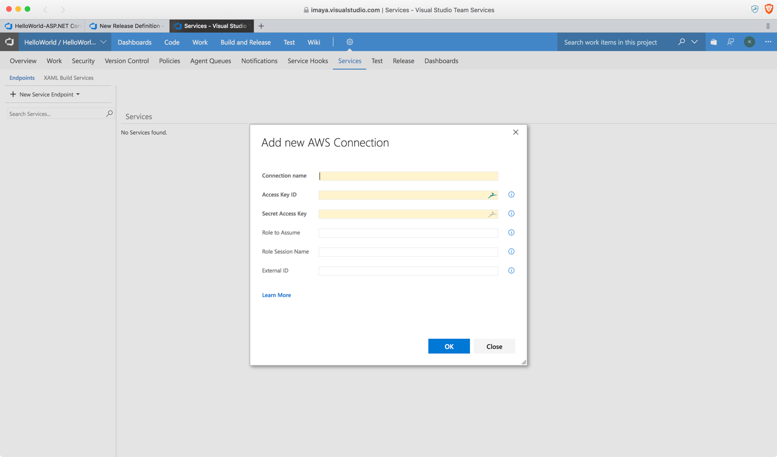

1. Once you click **OK** and save, you should see a screen similar to this.

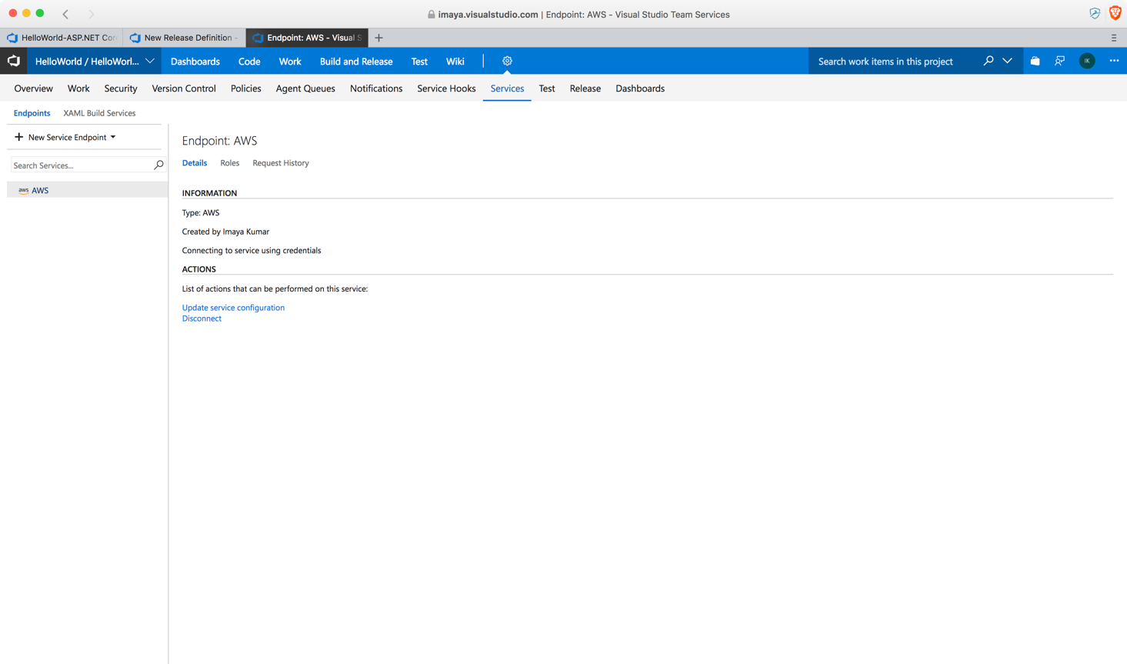

1. Now, go back to your Release definition screen and give the new service endpoint name you just created. VSTS should automatically resolve the name from its configuration. Enter the region in which your sample Beanstalk application was created. Fill in the Application name and Environment name from the AWS console. Select **ASP.NET (Source Web Deploy Archive)** option under Deployment Bundle Type drop down options. Make sure this is selected correctly, otherwise the deployment will fail.

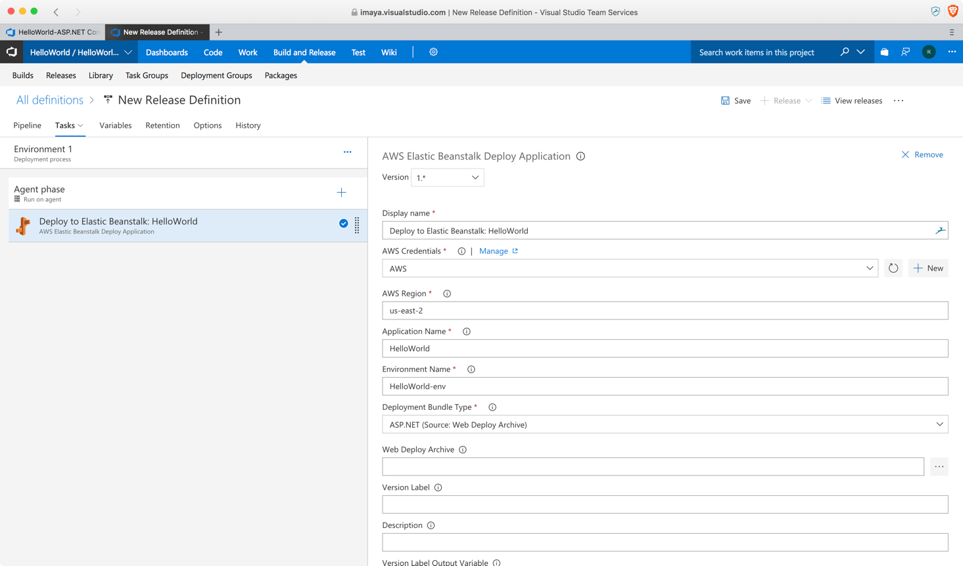

1. Now let's configure the location of the Build artifact for the Release definition to pick up. Click on **Artifacts** and select the options as shown below.

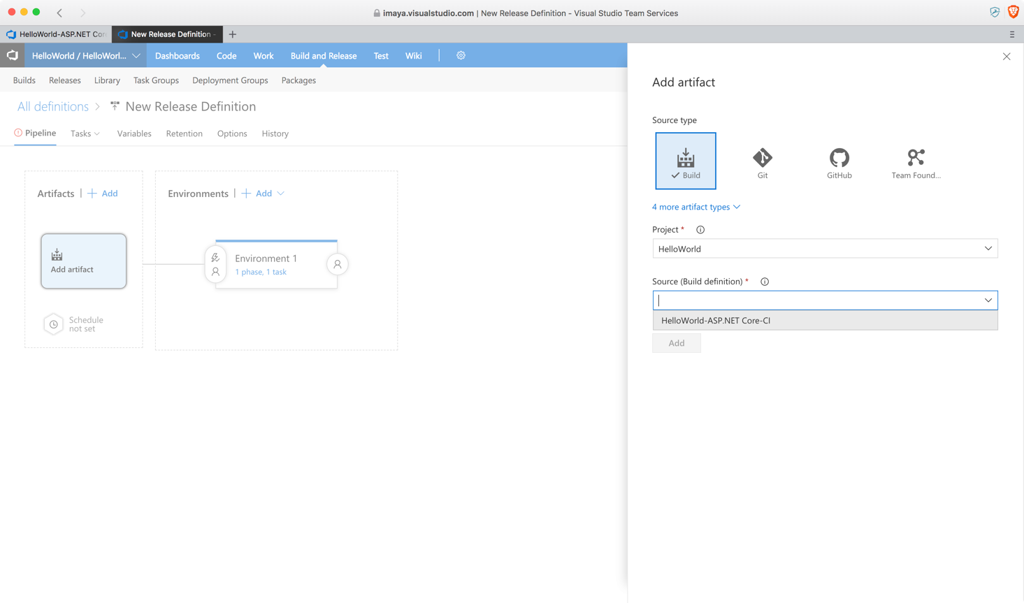

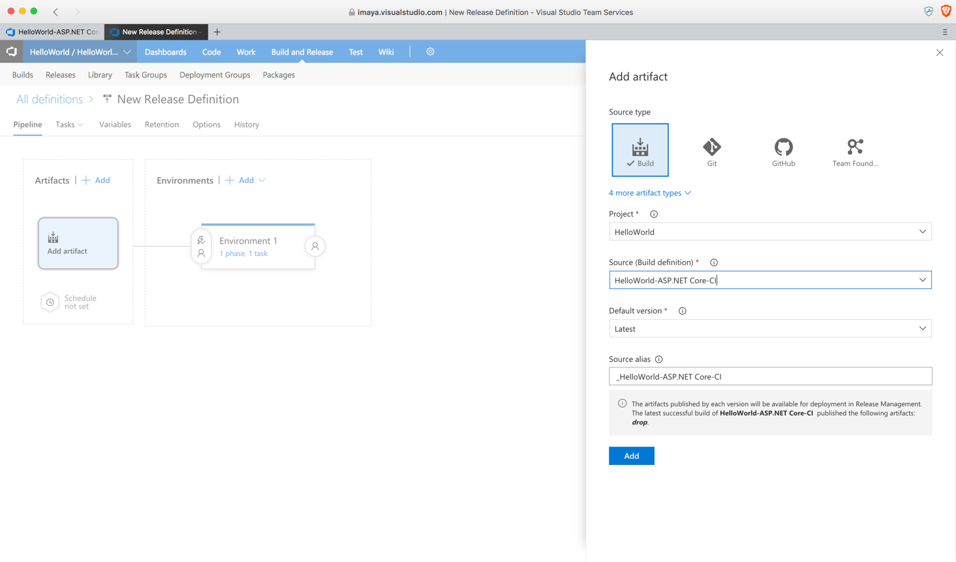

1. Now that we have configured the artifact location, go back to the Deploy task and click on the location picker button in the **Published Application Path** field. You should see a screen like this. Select the HelloWorld.zip file as the option and click **OK.**

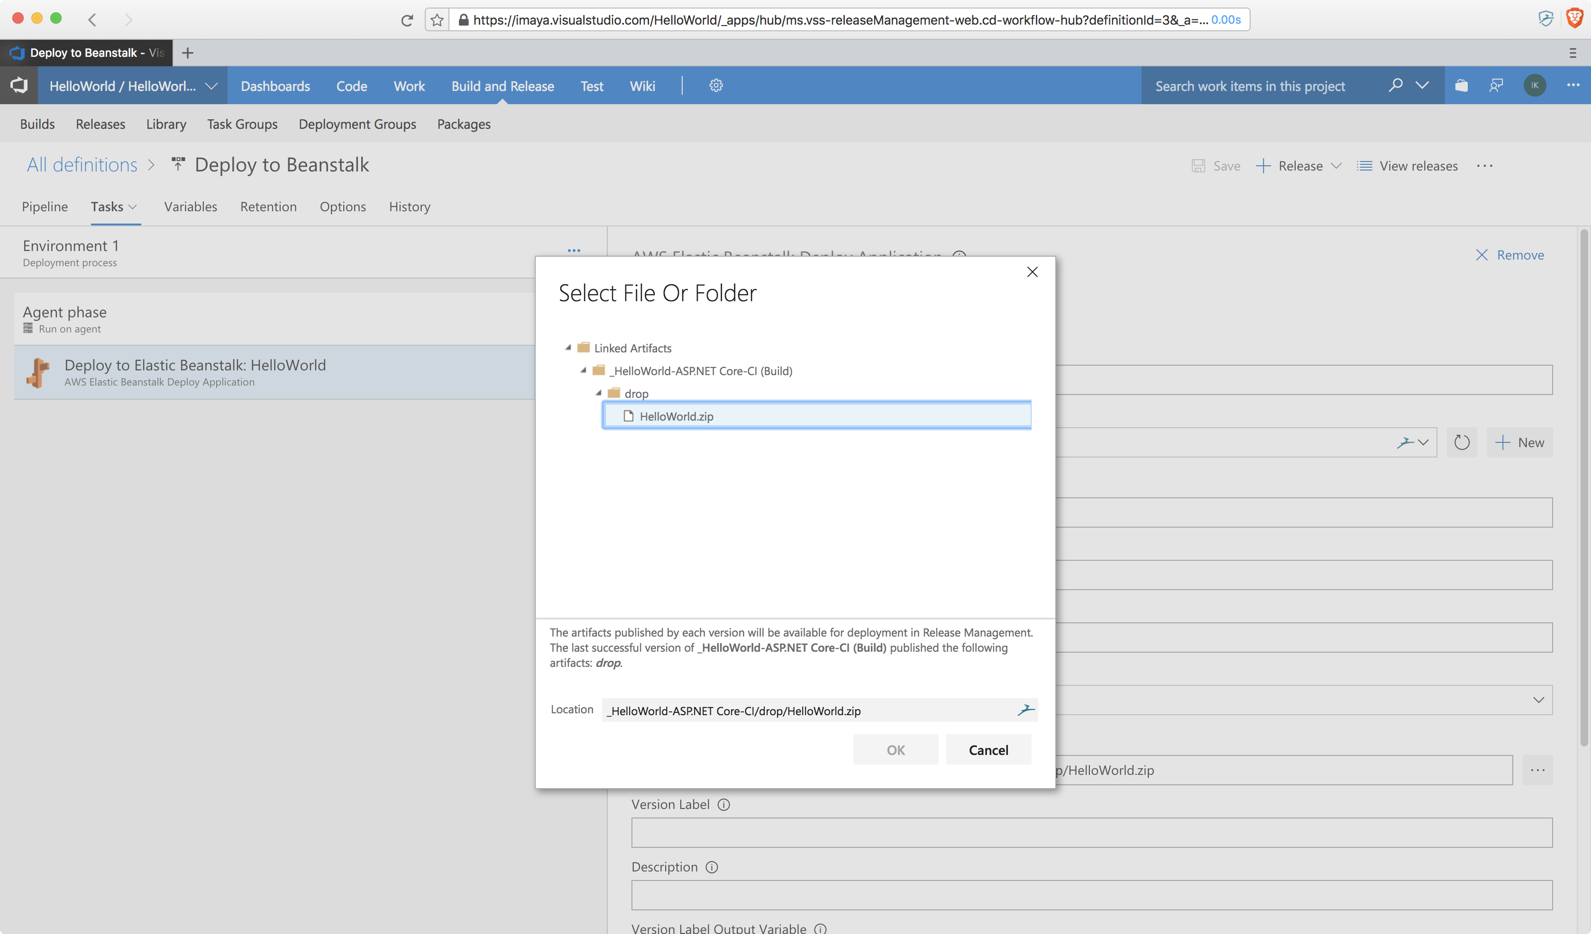

1. Your final configuration screen should look like this. Rename the release definition if you like and save.

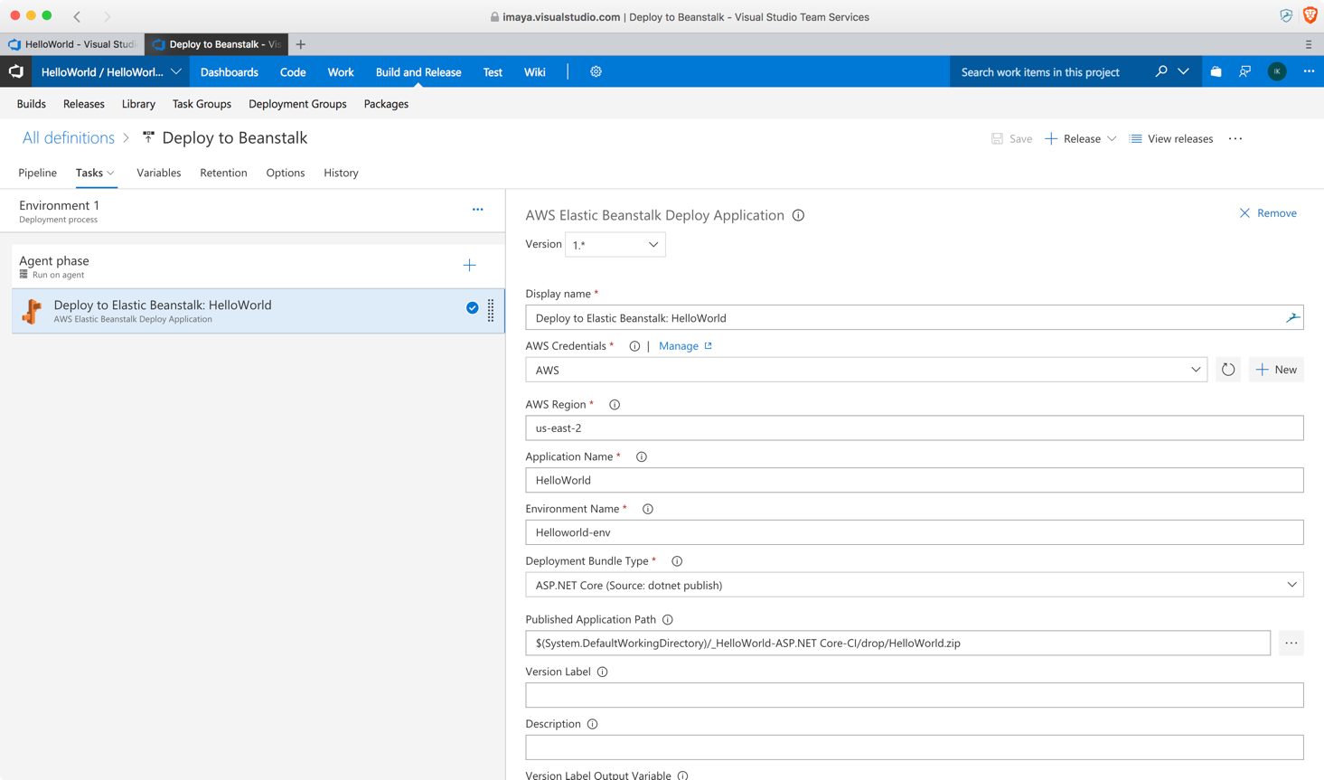

1. Go to your release definition and follow the steps below as shown in the screenshots to create a new release/deployment to the AWS Beanstalk instance.

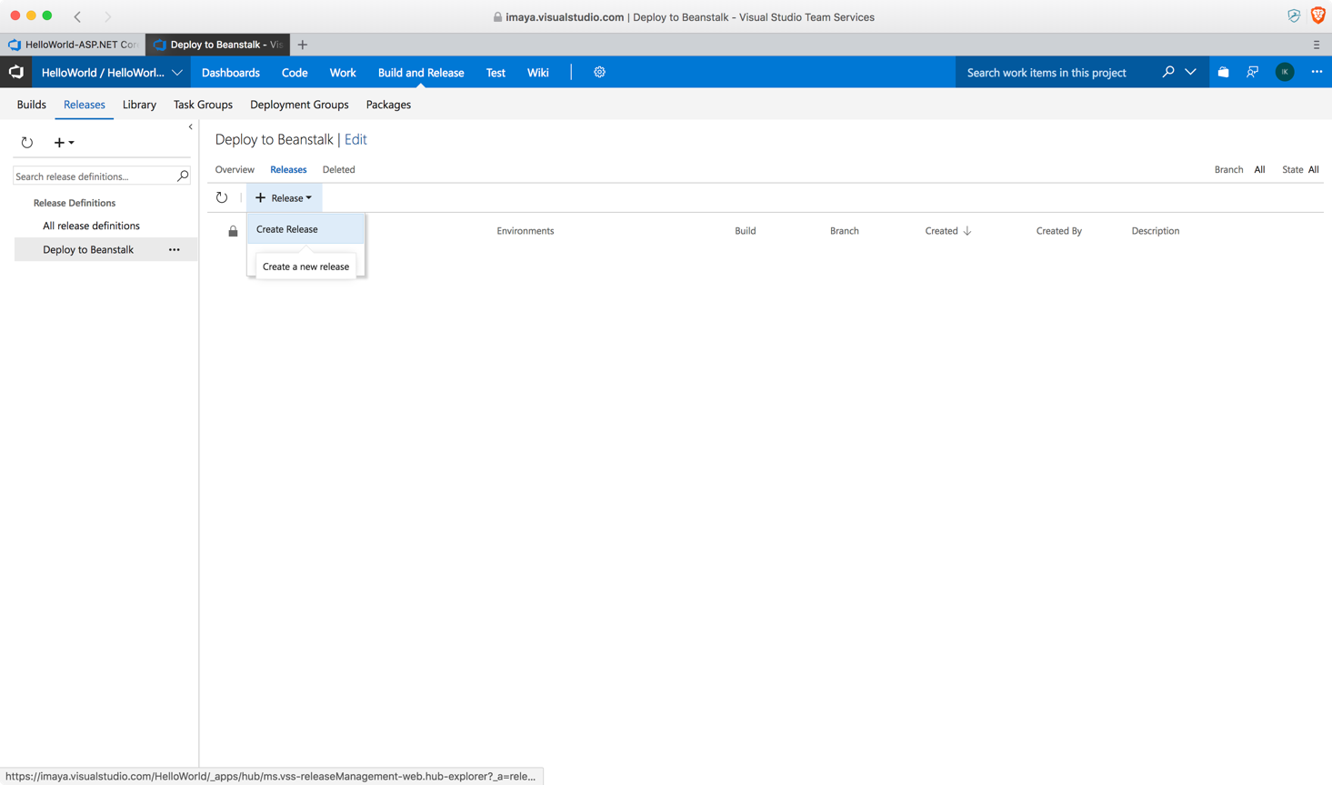

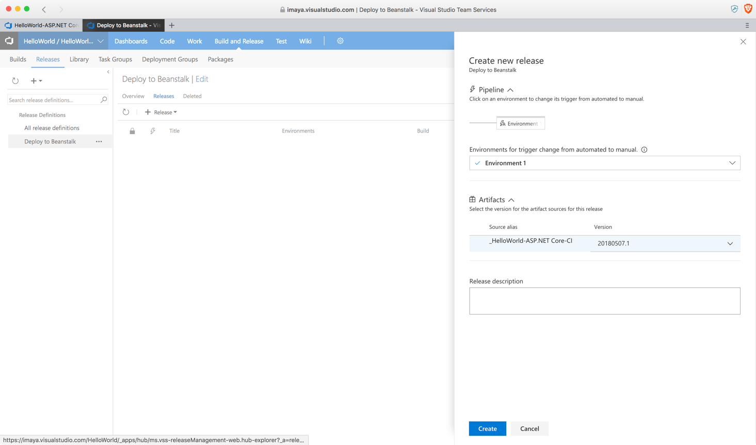

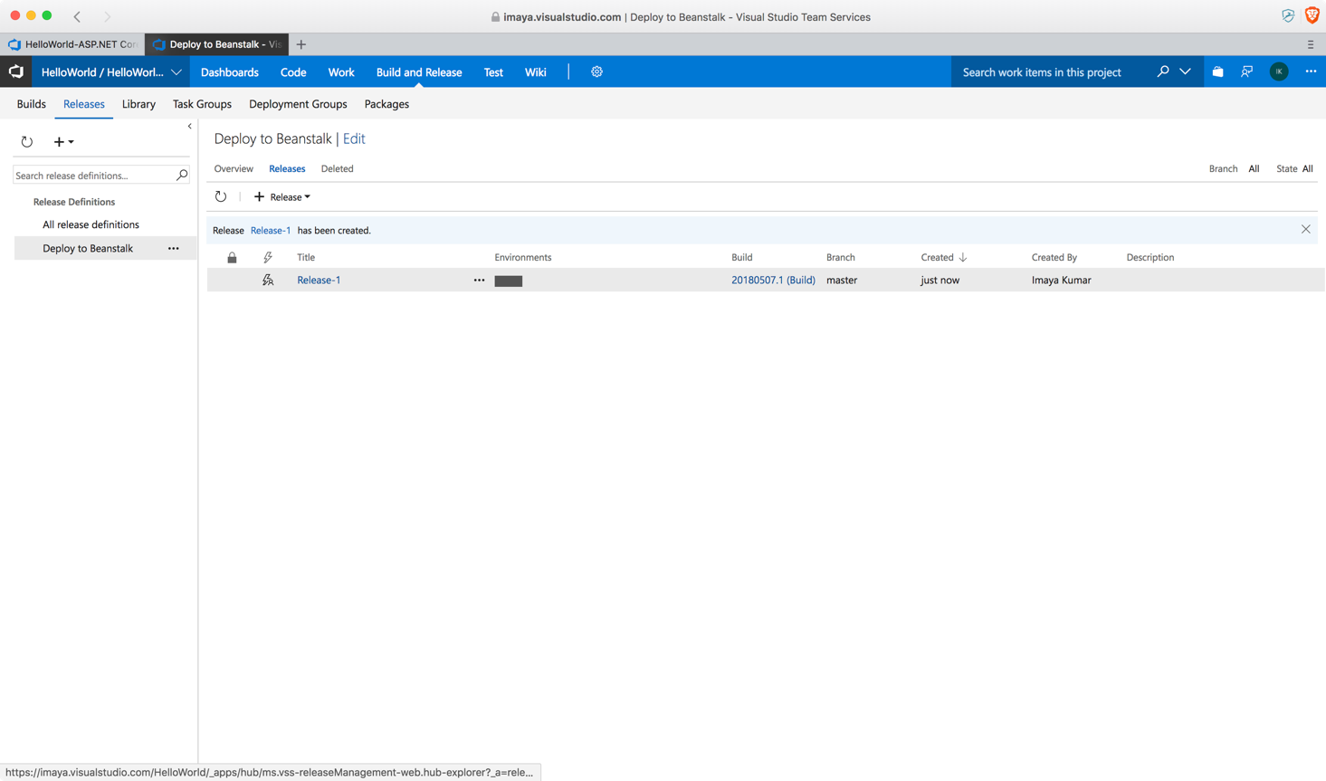

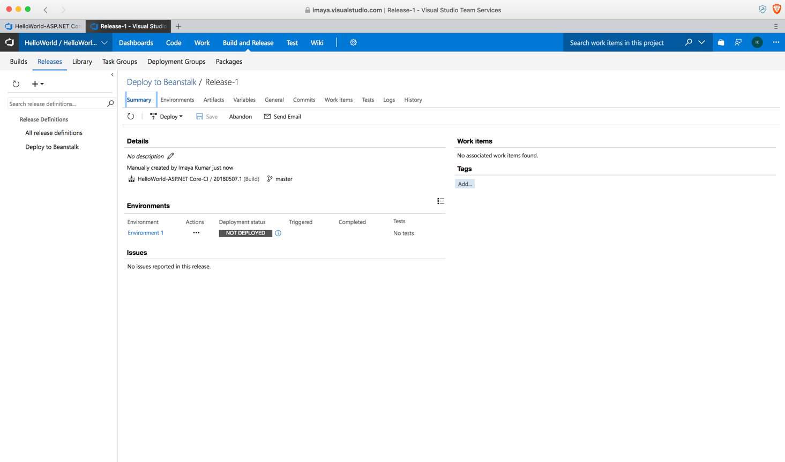

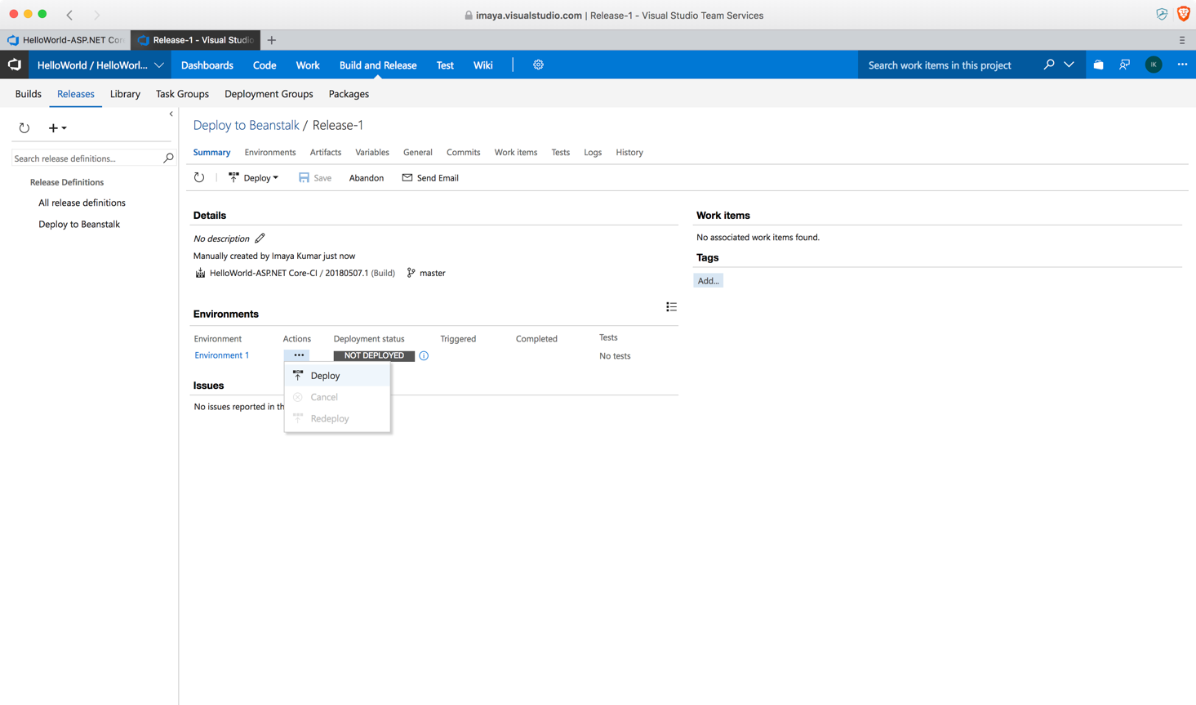

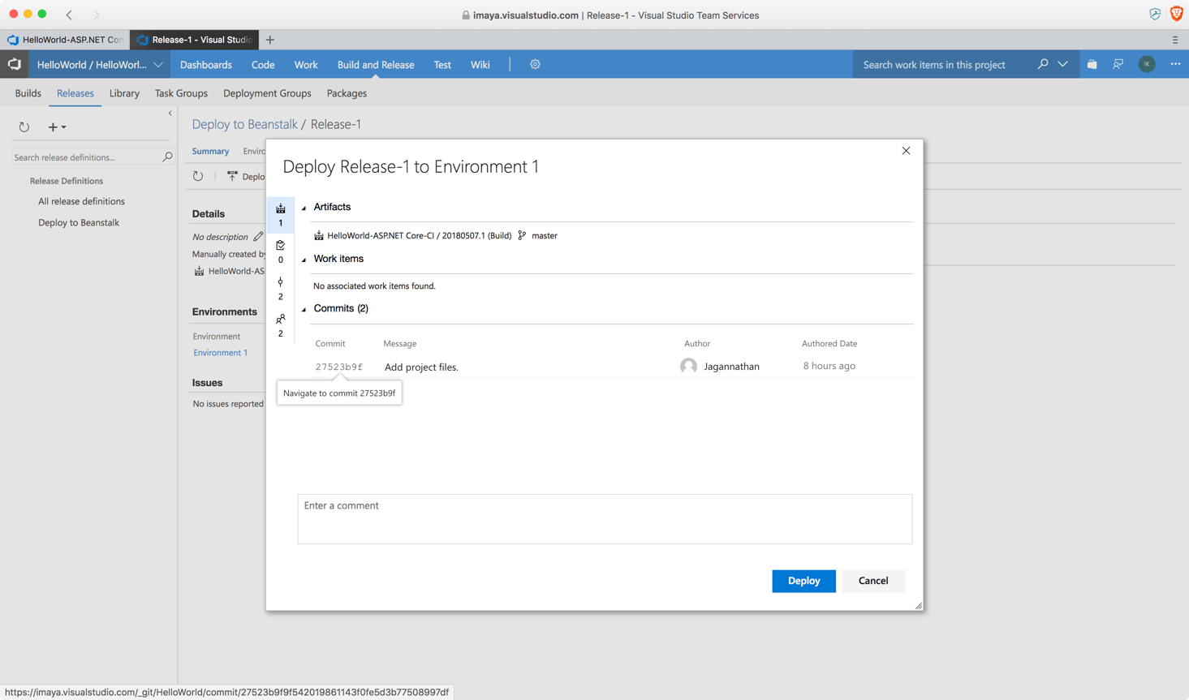

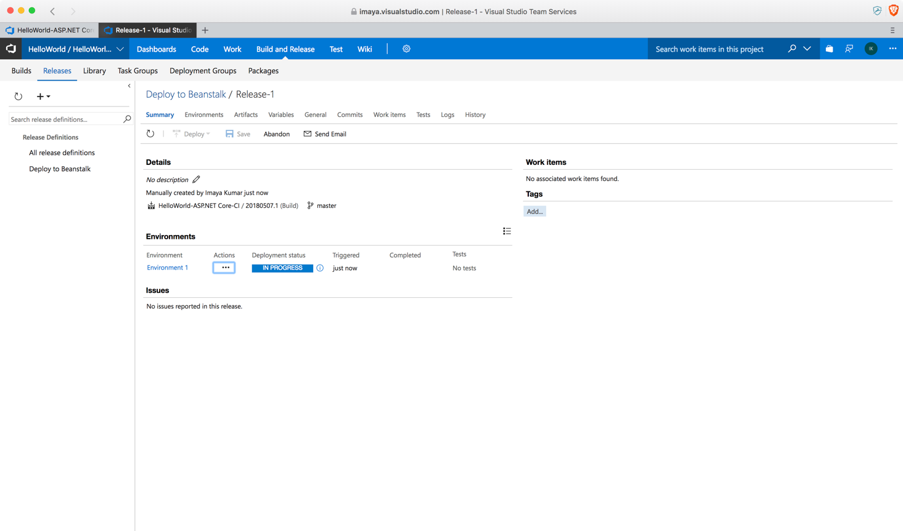

1. If you the deployment is successful, your VSTS screen will look like this.

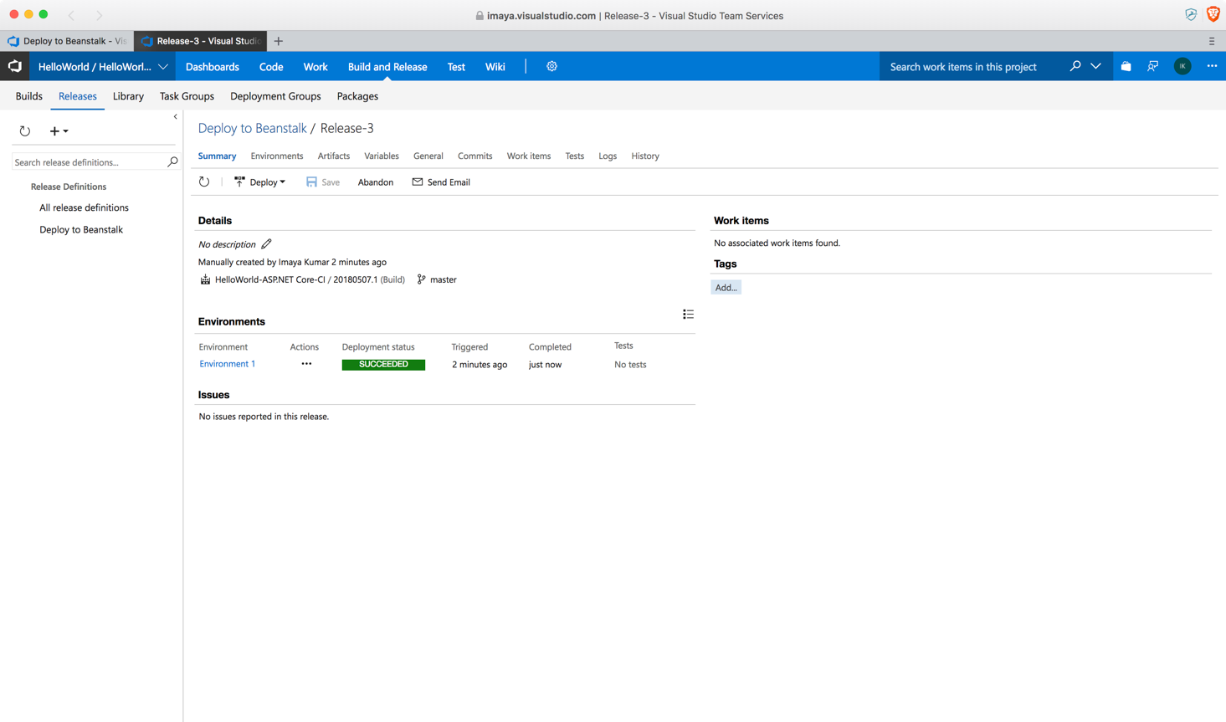

1. Head over to your AWS Console and you should see a screen like this. Notice that the **Recent Events** table is indicating a successful deployment.

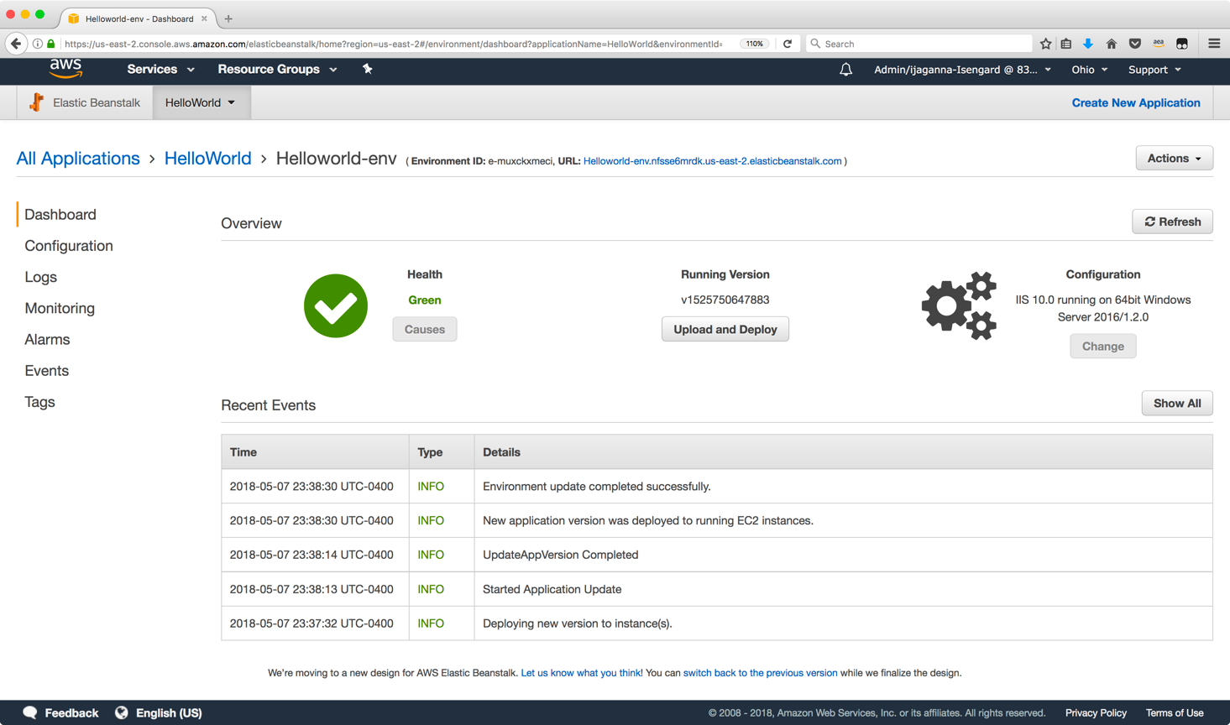

1. Once you click on the URL, your browser should now show the default ASP.NET Core application that you pushed through the CICD pipeline instead of the sample Beanstalk application that was originally created.

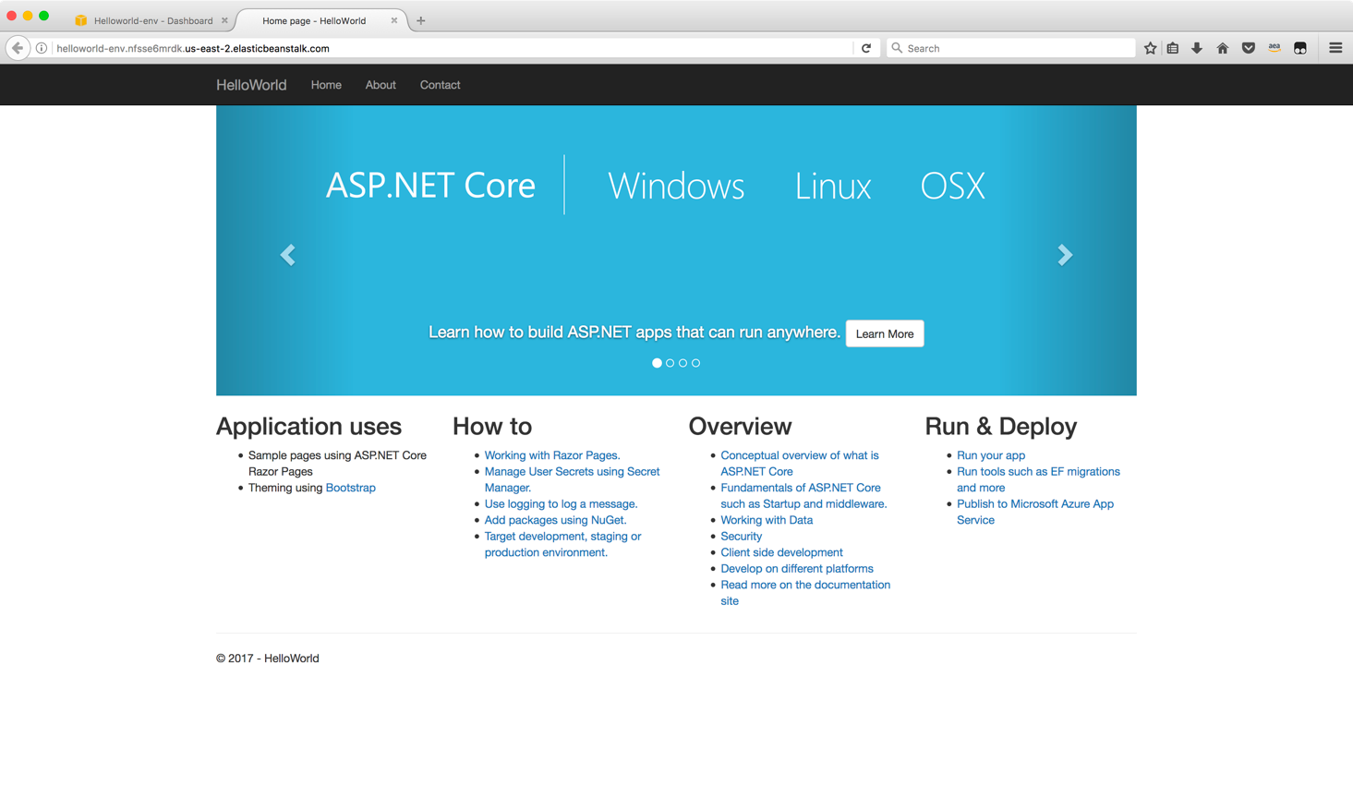

### Additional Info

If you had installed the AWS Toolkit for Visual Studio, you will be able to make use of many of its exciting features. For example, you will be able to see event logs, monitoring graphs and much more as shown below.

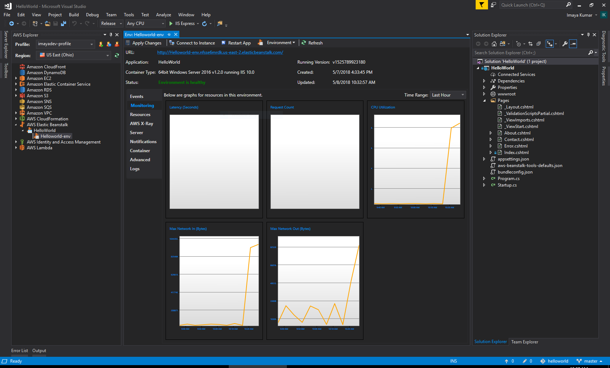

![HelloWorld - Microsoft Visual Studio 
File Edit 'Clew Project Build Debug Team 
Release 
AWS Explorer 
Profile: imayadev-profile 
Regk)n: US East (Ohio) 
Amazon CloudFront 
Amazon DynamoDB 
Amazon EC2 
Amazon Elastic Container Service 
Amazon ROS 
Amazon S3 
Amazon SNS 
Amazon SQS 
Amazon VPC 
AWS CloudFormation 
AWS Elastic Beanstalk 
HelloWorld 
Helloworld-env 
AWS Identity and Access Management 
AWS Lambda 
Tools Test Analyze Window 
Help 
Any CPU 
. Helloworld-env -a 
IIS Express • 
Apply Changes I Connect to Instance Restart App Environment • I Refresh 
URL: 
Application: 
Container Type: 
Status: 
Monitoring 
Resourcs 
AWS x-Ray 
Notifications 
Contailk•r 
http://Helloworld-env.nfsse6mrdk.us-east-2.elasticbeanstalk.com/ 
HelloWorld 
64bit Windows Serv•er 2016 VI.2.O running IIS 10.0 
Running Version: vi525789923180 
Created: 
5/7/2018 4*345 PM 
5/8/2018 1023257 AM 
Environment is healthy 
Event Time 
5/8/2018 12:16:54 AM 
5/8/2018 AM 
5/8/2018 AM 
5/8/2018 AM 
5/8/2018 AM 
5/8/2018 AM 
5/8/2018 AM 
5/7/2018 PM 
5/7/2018 11:54:57 PM 
5/7/2018 PM 
5/7/2018 PM 
5/7/2018 11:54:07 PM 
5/7/2018 PM 
5/7/2018 PM 
5/7/2018 1143•26 PM 
5/7/2018 11:4308 PM 
5/7/2018 114308 PM 
5/7/2018 1142:37 PM 
5/7/2018 PM 
5/7/2018 PM 
5/7/2018 PM 
5/7/2018 11:38:14 PM 
5/7/2018 PM 
5/7/2018 PM 
5/7/2018 PM 
5/7/2018 PM 
5/7/2018 PM 
Event Type 
NFC' 
NFC' 
INFO 
NFC' 
INFO 
NFC' 
INFO 
Version Label Event Details 
Environment update is starting. 
Environment update completed successfully. 
Successfully deployed new configuration to environment. 
New application version was deployed to running EC2 instances. 
Deploying new version to instance(s). 
Updating environment Helloworld-env's configuration settings. 
Environment update is starting. 
Environment update completed successfully. 
New application version was deployed to running EC2 instances. 
Started Application Update 
UpdateAppVersion Completed 
Deploying new version to instance(s). 
Environment update is starting. 
Environment update completed successfully. 
New application version was deployed to running EC2 instances. 
UpdateAppVersion Completed 
Started Application Update 
Deploying new version to instance(s). 
Environment update is starting. 
Environment update completed successfully. 
New application version was deployed to running EC2 instances. 
UpdateAppVersion Completed 
Started Application Update 
Deploying new version to instance(s). 
Environment update is 
Successfully launched environment: Helloworld-env 
Environment health has been set to GREEN ](